**Name: Rohit. Patil**

**Student ID: 106901463**

**Project Guide: Dr. David Ruby**

**Project: Online Job Recruitment Website**

Online Job Recruitment Website

## Overview:

Online Job Recruitment Website is designed for recruitment of Job Seekers through several modules provided in the website. It consists of mainly two sections Job Seekers (Employees) and Job Providers (Employers). In each sections there are several modules used for different purposes related to Jobs. It has an easy to use interface through which Job Seekers and Job Providers can complete the necessity task as per their needs. Today the world is in need for easy interaction web based applications for every purpose, hence this Online Job Recruitment Website provides several features which fulfill this needs. The two major sections Job Seeker and Job Provider of the website have several features through which the use of this website becomes much easier.

Several features of the website are listed below as per their purpose in the web based application:

The layout of Online Recruitment Website is linked to one main page below that is the Index page through which all other pages are connected to each other:

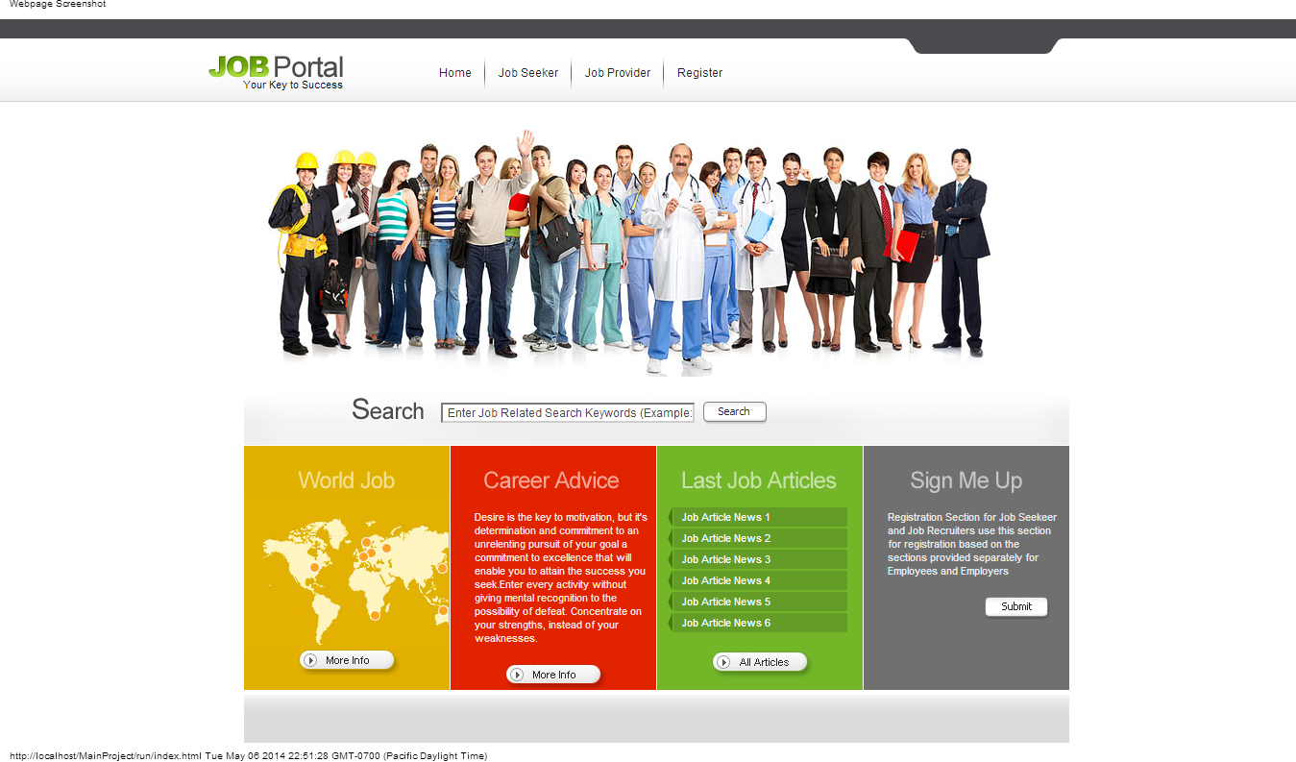

The Online Web Recruitment Website is mainly divided into two main sections Job Seeker and Job Provider Section:

Below is the form which states the two main sections:

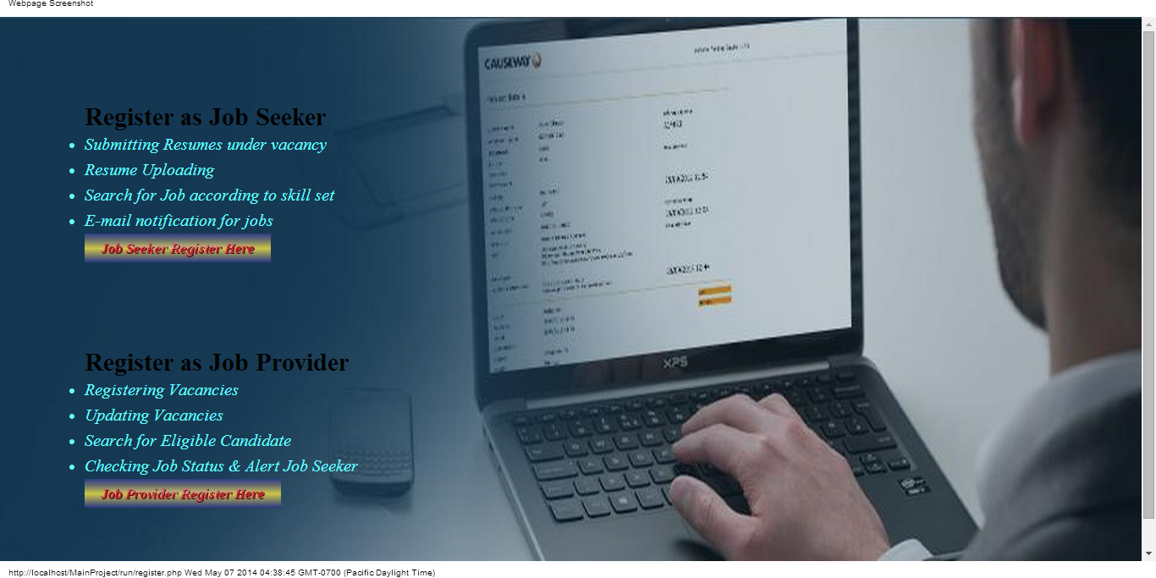

The above form shows the Job Main Sections for the Online Job Recruitment Website.

## Job Seeker Section:

Job Seeker Section consists of modules like:

* Job Seeker Registration
* Forgot Password
* Login Job Seeker
* Homepage for Job Seeker
* Account Details (Update Feature)
* Submitting Resume under Vacancy
* Resume Uploading
* Searching Job according to skill set and category
* E-mail notification for the Job applied
* Career Advice
* Services

**Job Seeker Registration Section:**

The Job Seeker Registration section is designed for registering to the website for using the features of the Recruiting website. It consists of registration form through which Job Seekers Registers to the website using username and password for the account activation. The Job Seeker fills in the details and completes the registration. After submitting registration account activation link is send to the registered Email-ID and with help of the activation the Job Seeker gets registered to the Online Recruitment Website. There are certain prompt messages used for notifying user whether there is an error during registration process so the user can fill in the error correctly and can complete the registration easily.

**Features used in Registration form of Job Seeker:**

In designing the form the use of Ajax tool and JavaScript is used to prompt the error messages while registering the website. The main feature of it is Username and Email-ID check availability, Email-ID validity and Username strength notification. It fetches the data from the database without loading the page with the help of JavaScript and Ajax Toolkit to check whether the Username and Email-ID is available or not and prompts the error message accordingly. It also has features like automatic loading of State Province for its Related Country. This feature helps to easy load of state instead of searching through wide list

Below is the Job Seeker Registration Form Snapshot with its prompt messages used: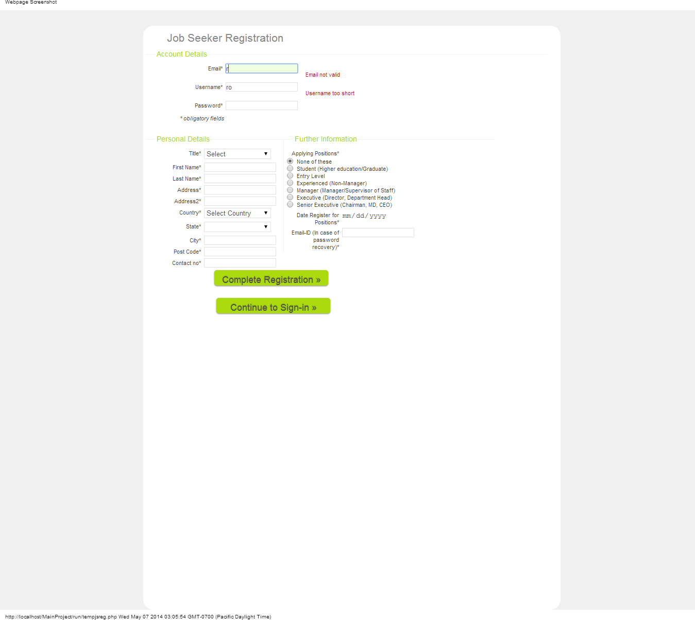

The above form states the Email-ID validity and Username Strength message.

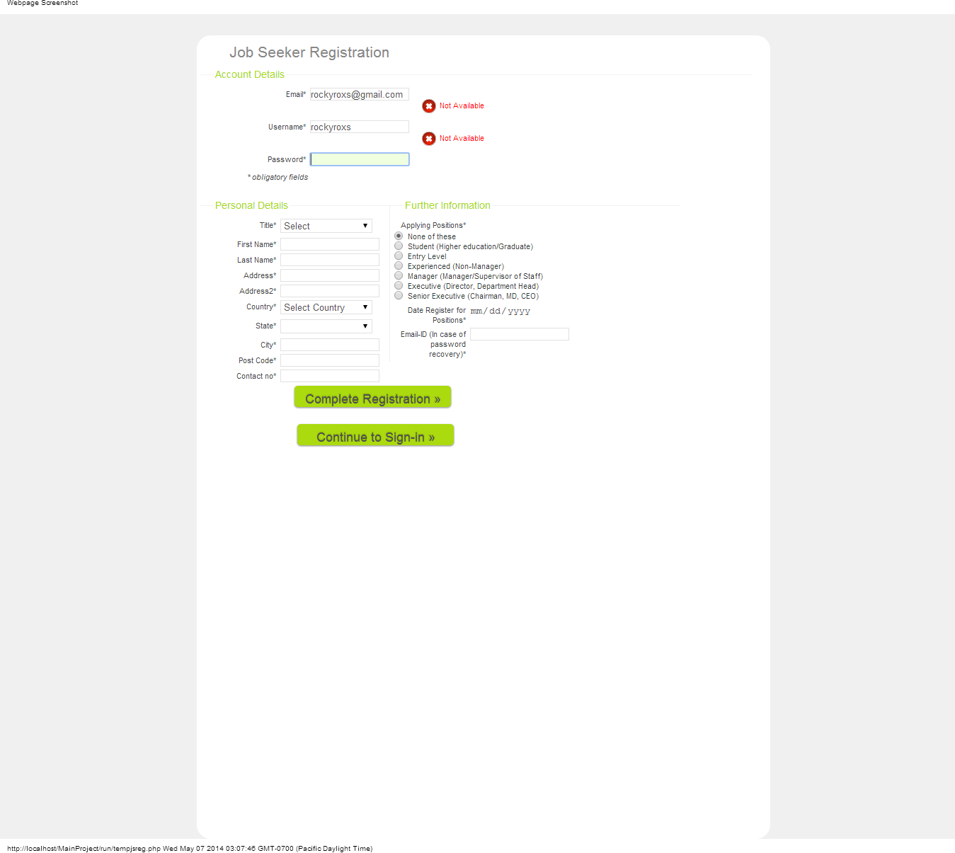

The above form prompts the error message of Email-ID and Username Availability.

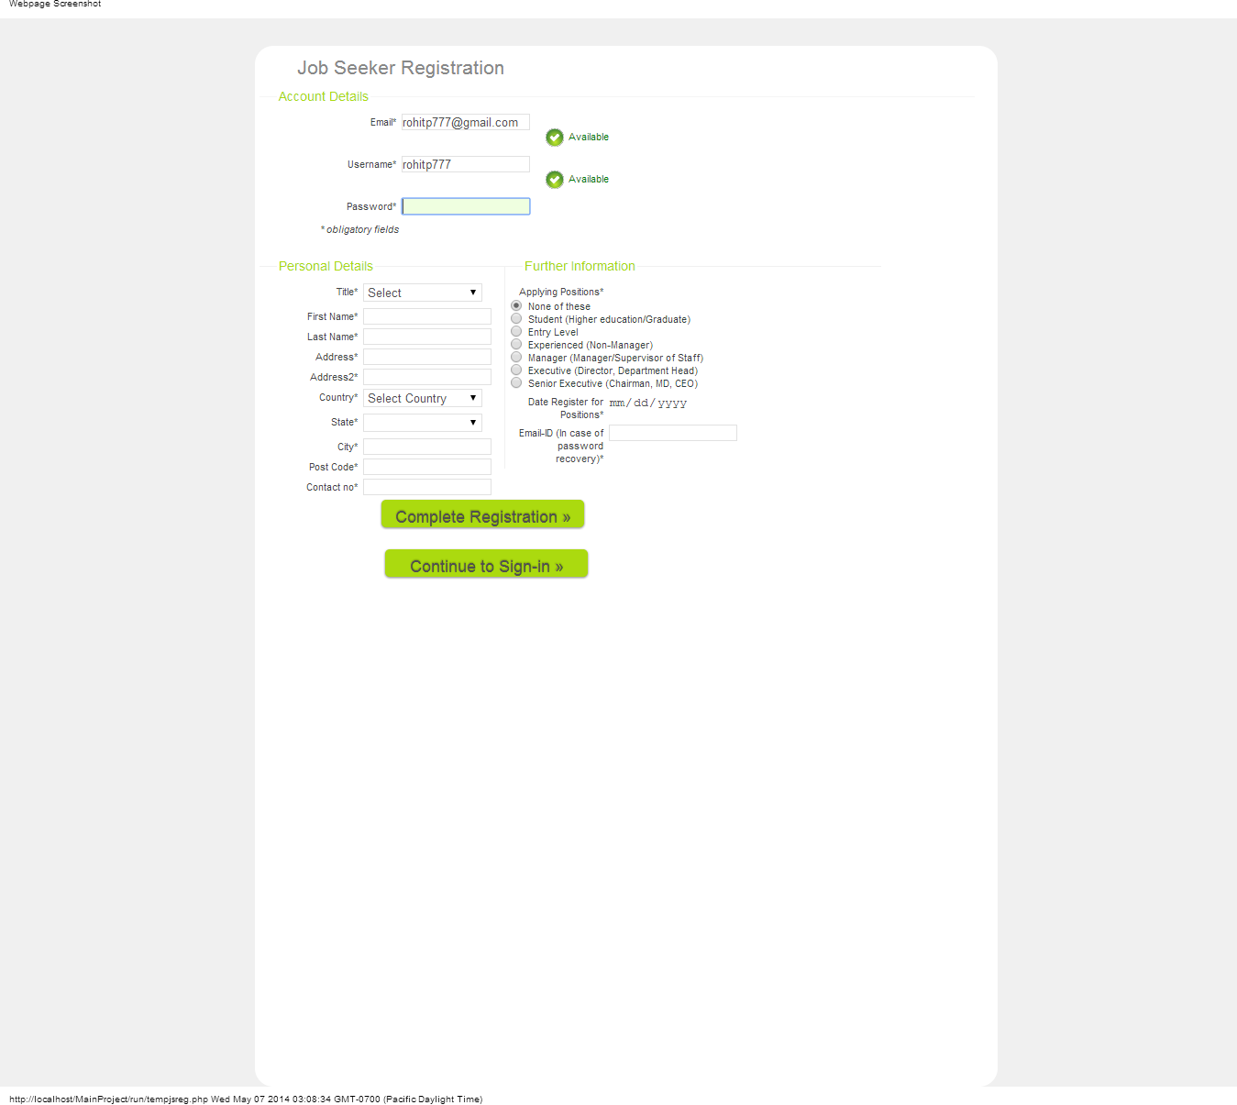

The above form prompts the username and password available message.

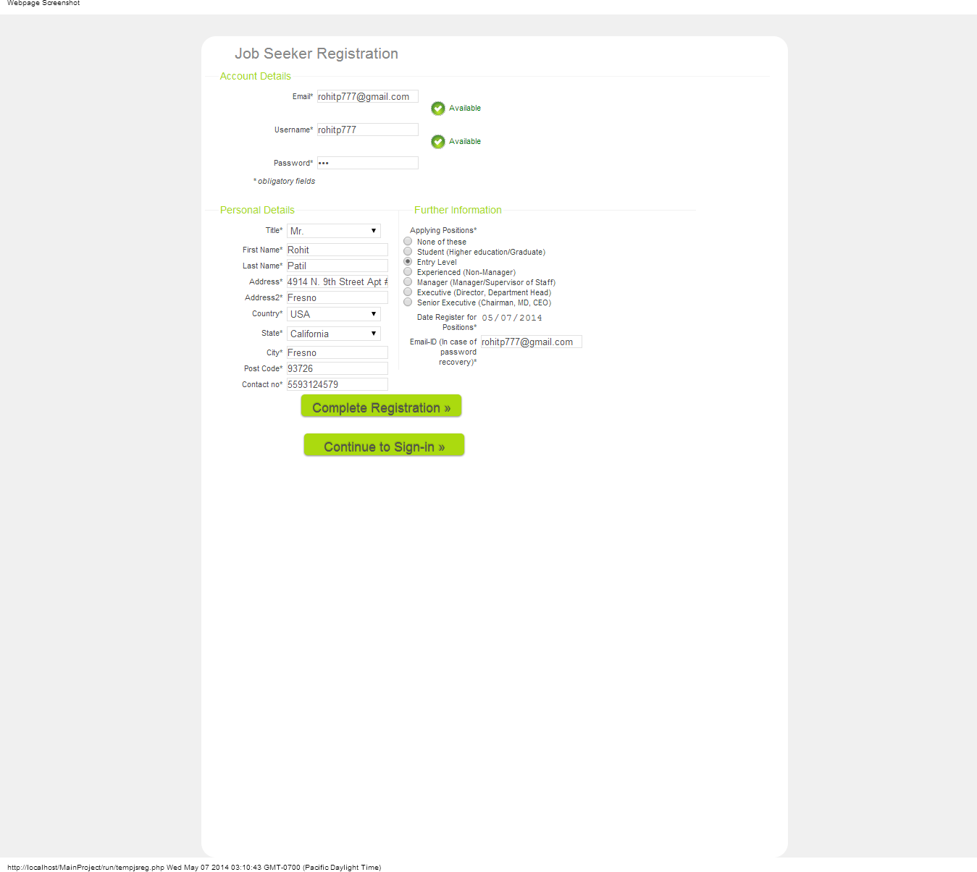

The above form is the completed Registration Form for Job Seeker Profile.

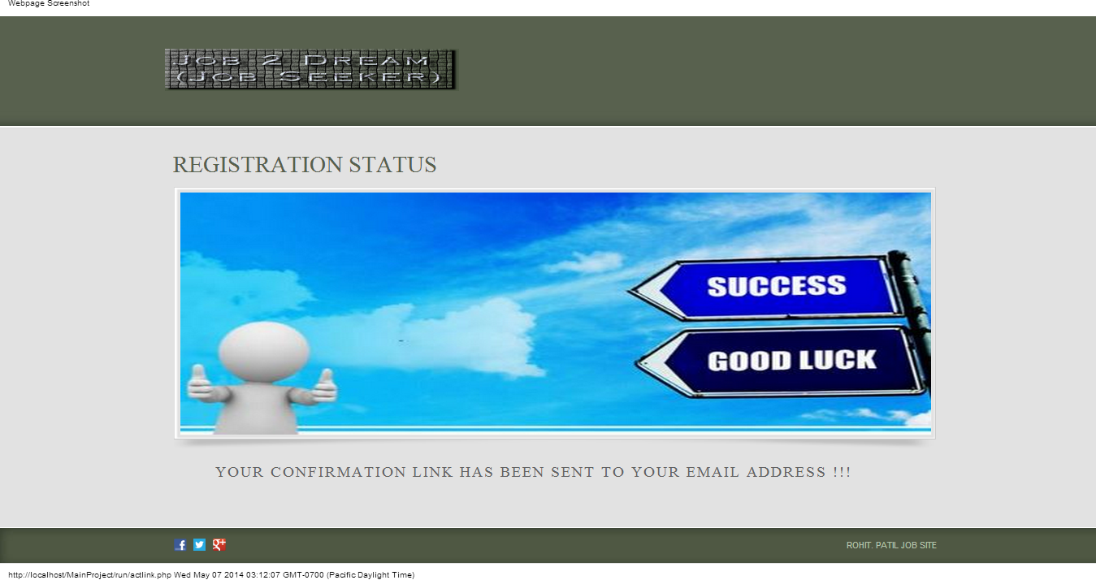

Above form is used to show the message for the Job Seeker that the Registration is complete and the confirmation activation link is send to the registered Email-ID.

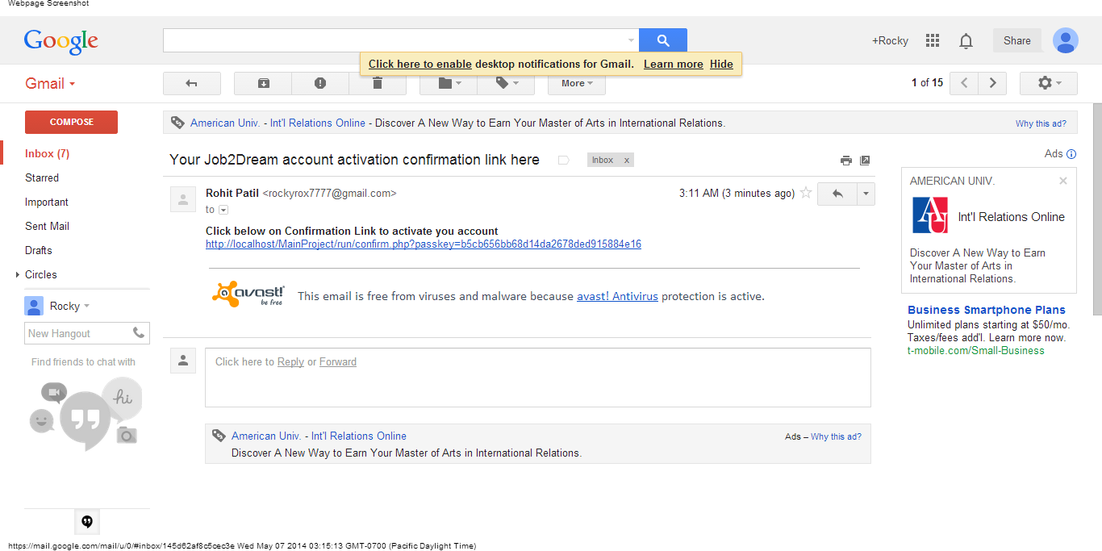

After Registering the Job Seeker gets the account activation link like above in his Email-ID through which after clicking on the link the account gets activated for his Online Job Recruitment Website.

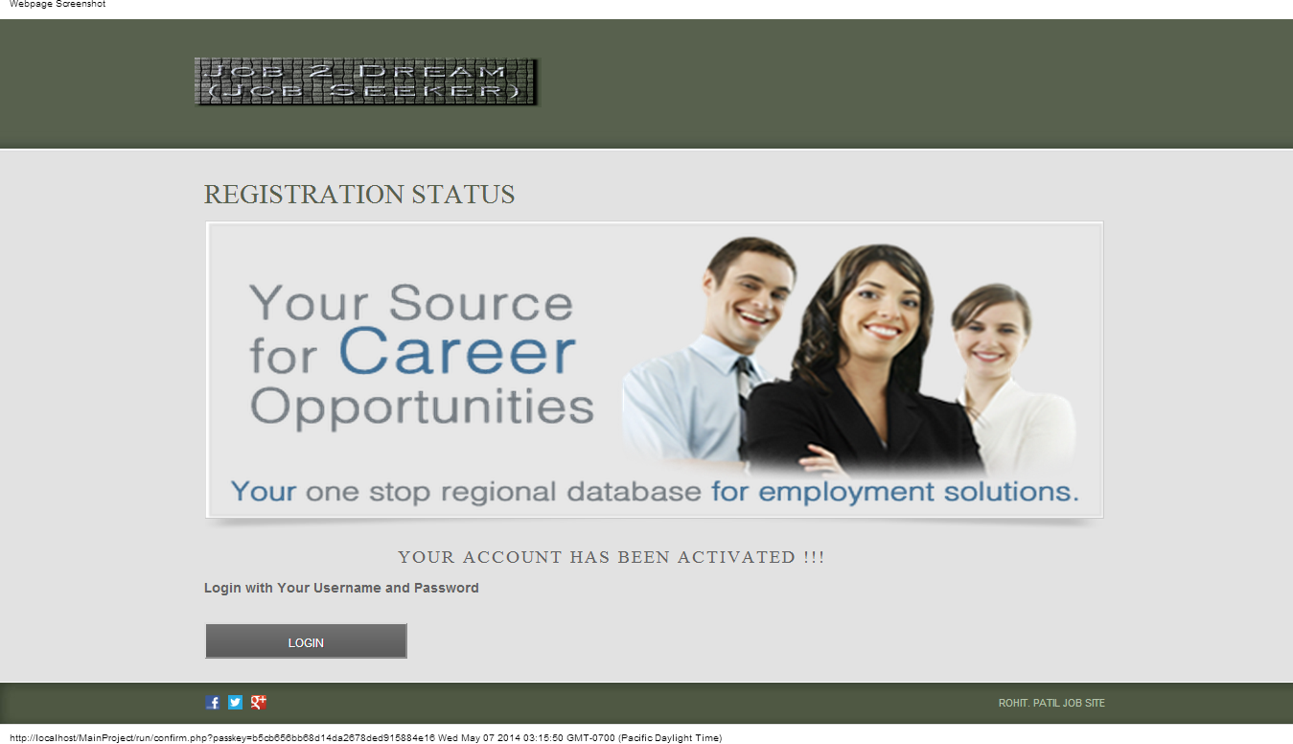

The above form notify the Job Seeker that his account is been activated and he can Login through his Username and Password through the Login Button.

**Forgot Password Section:**

This Section is used when the Job Seeker forgets his password or wants to update his password. This feature helps him to get his Email-ID and Update password notification link through his registered Email-ID. The Job Seeker can update his password by clicking on the link and the prompts messages accordingly help him throughout the process.

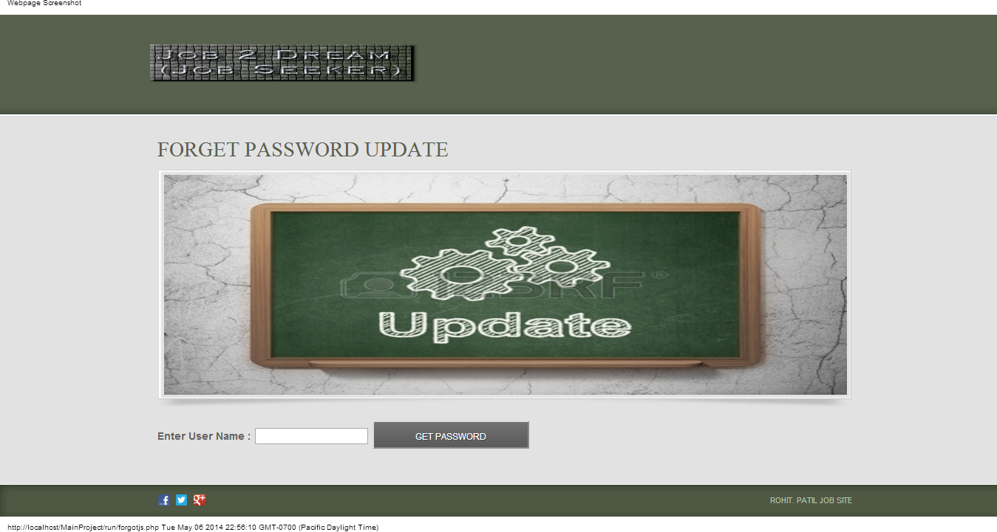

The above form is used to get the password update through the registered Email-ID by inputting the username field.

After completing the username field the user gets Email regarding updating the password link.

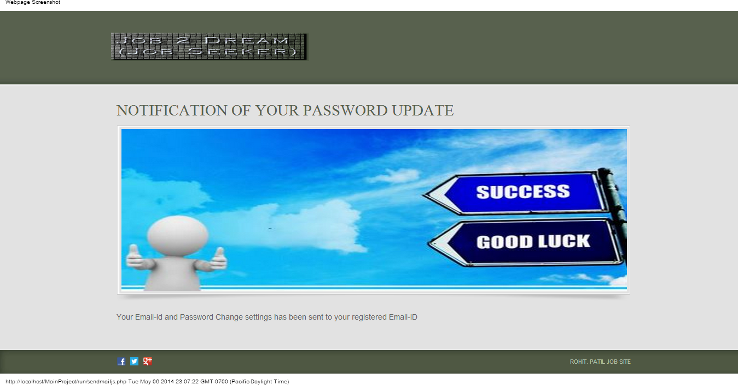

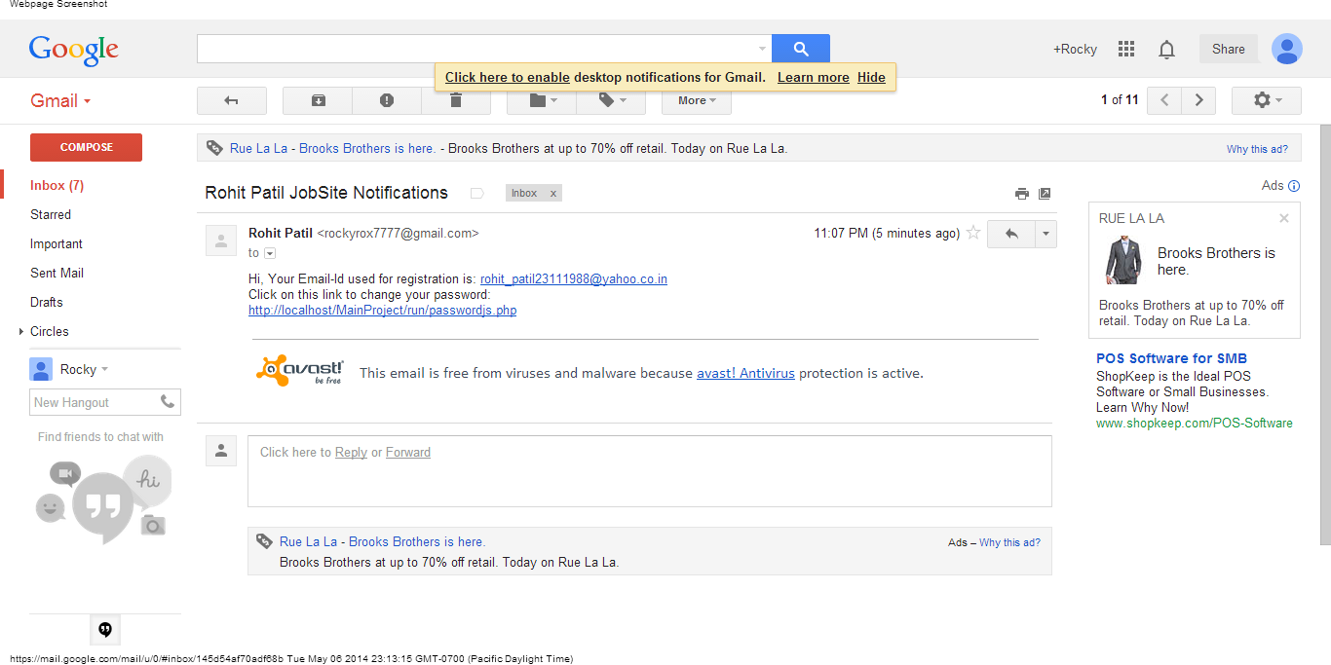

The Job Seeker gets the Email notification with the password update link and the Email-ID used during the registration.

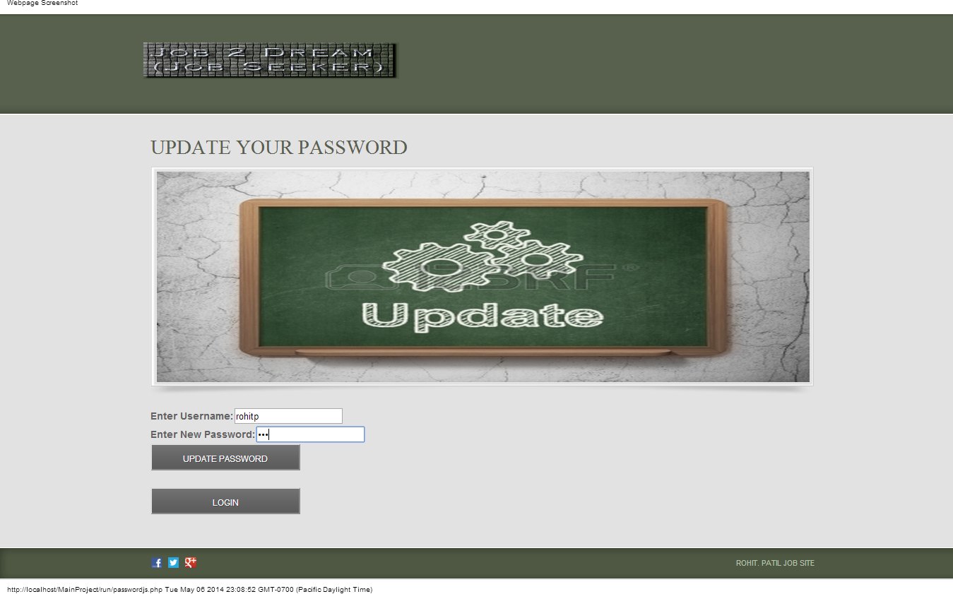

After clicking on the link for updating password through the Email-ID the link gets directed to the above form through which the user can update password easily.

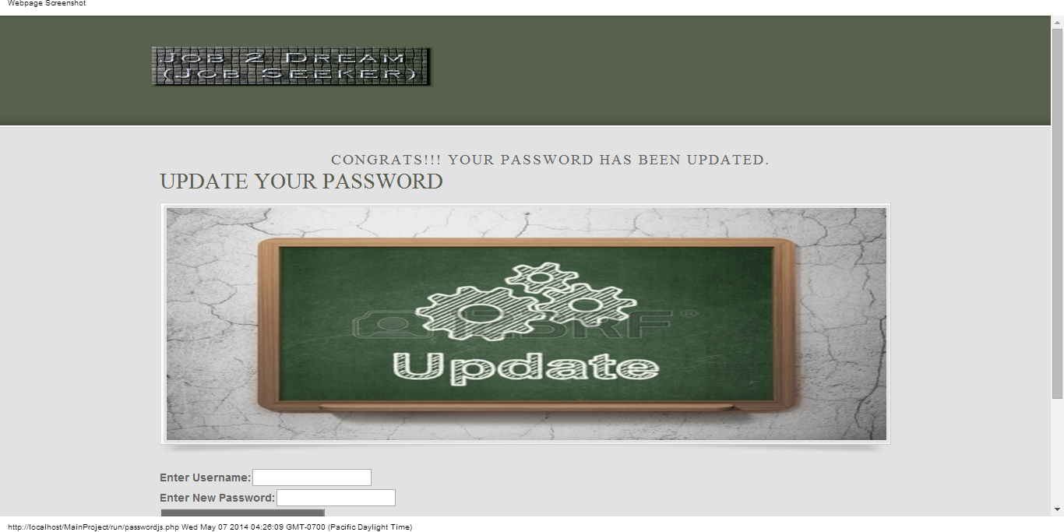

After filling in the details in the above form the password gets updated and the user gets the notification message accordingly.

**Login Job Seeker:**

The Login Job Seeker Section enables the registered Job seeker to Login into his account. The form is designed in such a way that the registered user gets an error message for Login if the Job Seeker by mistakenly inputs the wrong username or password and redirects the user to the error Login page. This makes user notified that he might inputted wrong username or password.

Below is the Login form for the Job Seeker:

Below is the Error Login Form for the Job Seeker:

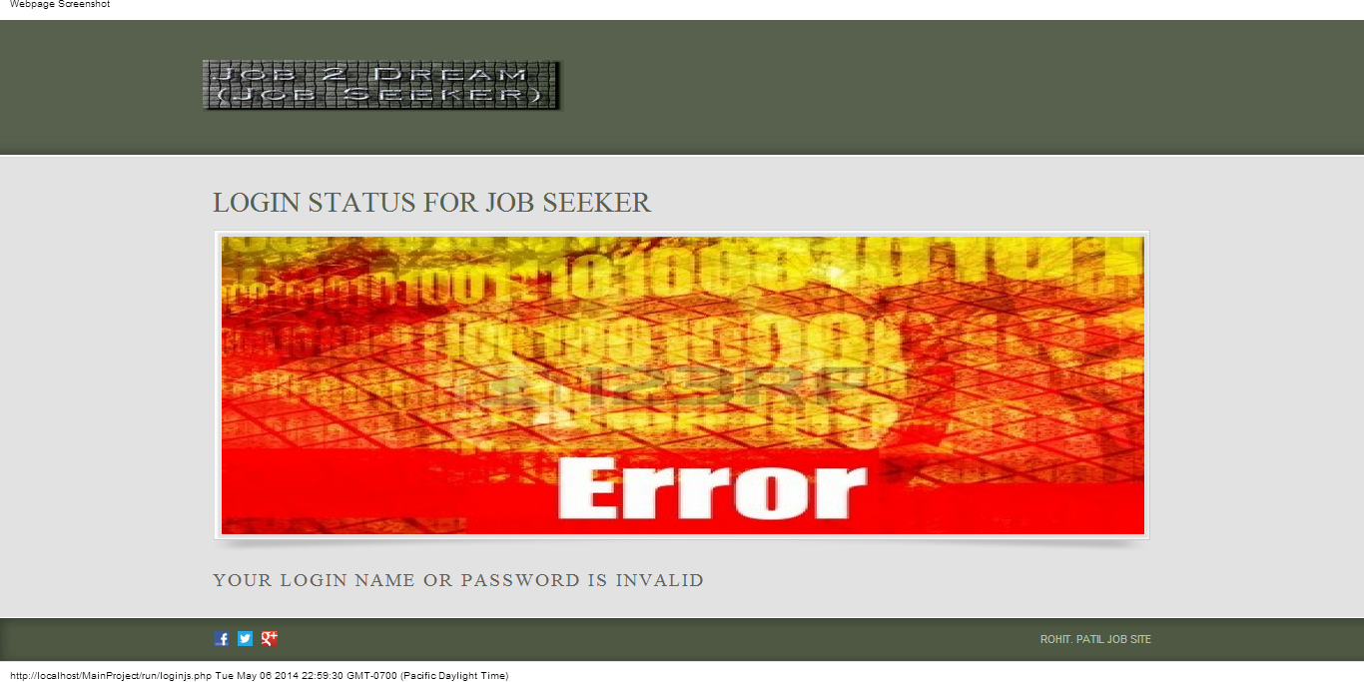

**Homepage for Job Seeker:**

It is the main page for the Job Seeker through which his entire account is connected. This is the page through which the Job seeker can navigate through different page related to his account. Below is the navigation list for the Job Seeker Homepage:

* Home is the index page for the Job Seeker
* My Details which has navigation links to My Account Details and Update Password
* Resume and Applications has a navigational link to Register CV/Resume
* Job Search has navigational link to Job Search by keywords and Job Search by category
* Career Advice
* Services
* Logout through can sign out from his account
* Navigational Link to Facebook, Twitter, Google Plus

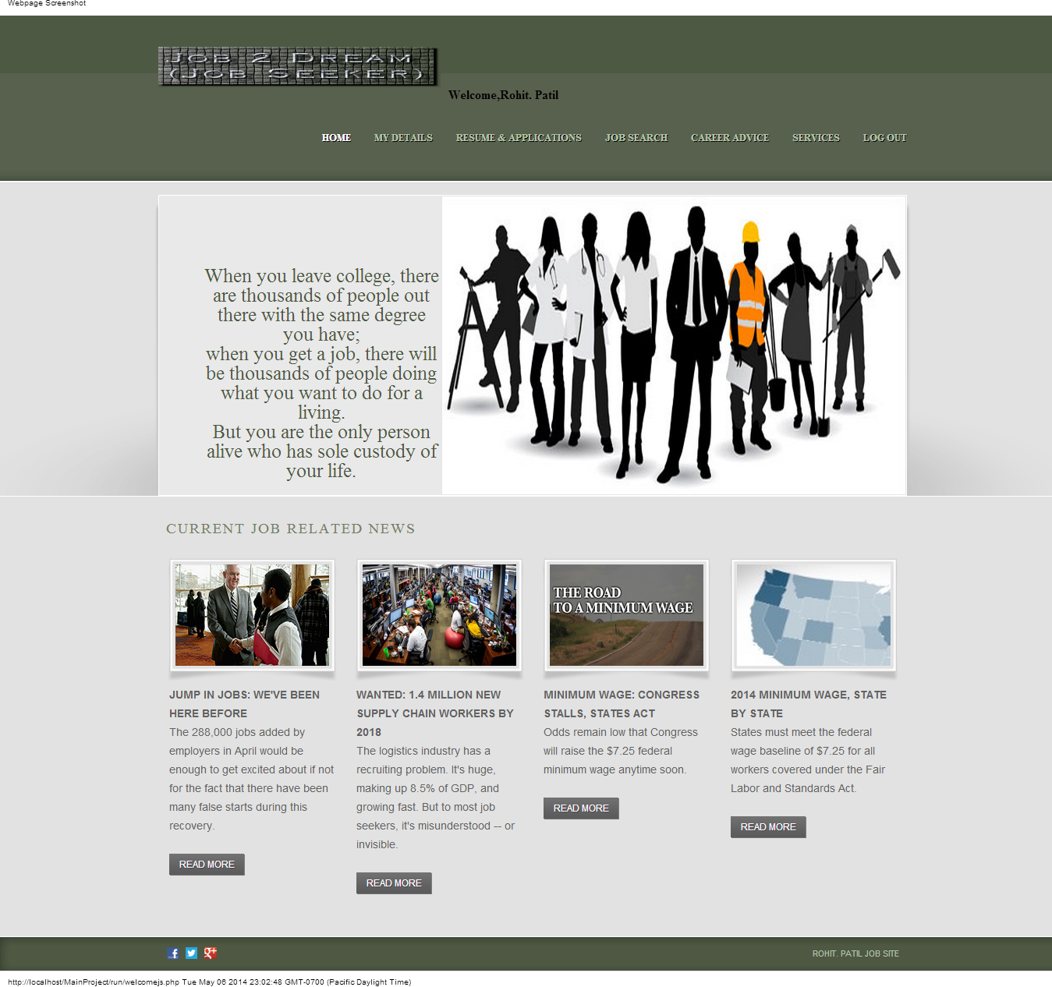

The above page is the homepage for the Job Seeker Profile when the Job Seeker logs into his account he gets directed to this page with the welcome message notification for his account.

**Account Details Page for Job Seeker:**

The account details page gives the user his account details used while registering to the website he can update this information as and whenever needed. There is a feature to save the page to the .pdf format also so that the user can use this details whenever required.

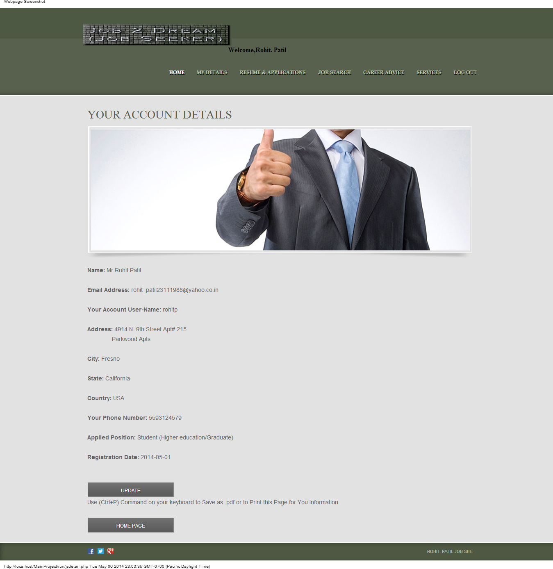

The above form is the account details form for the Job Seeker.

The user can update his personal information through Update button whenever needed.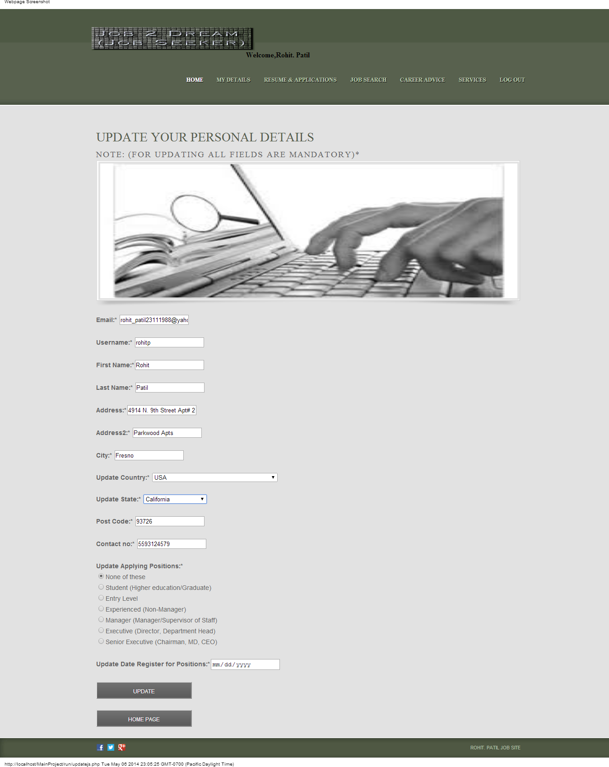

After the user inputs the updated data and clicks on the Update button the account details concerning his accounts gets updated and the user gets a prompt message like below. 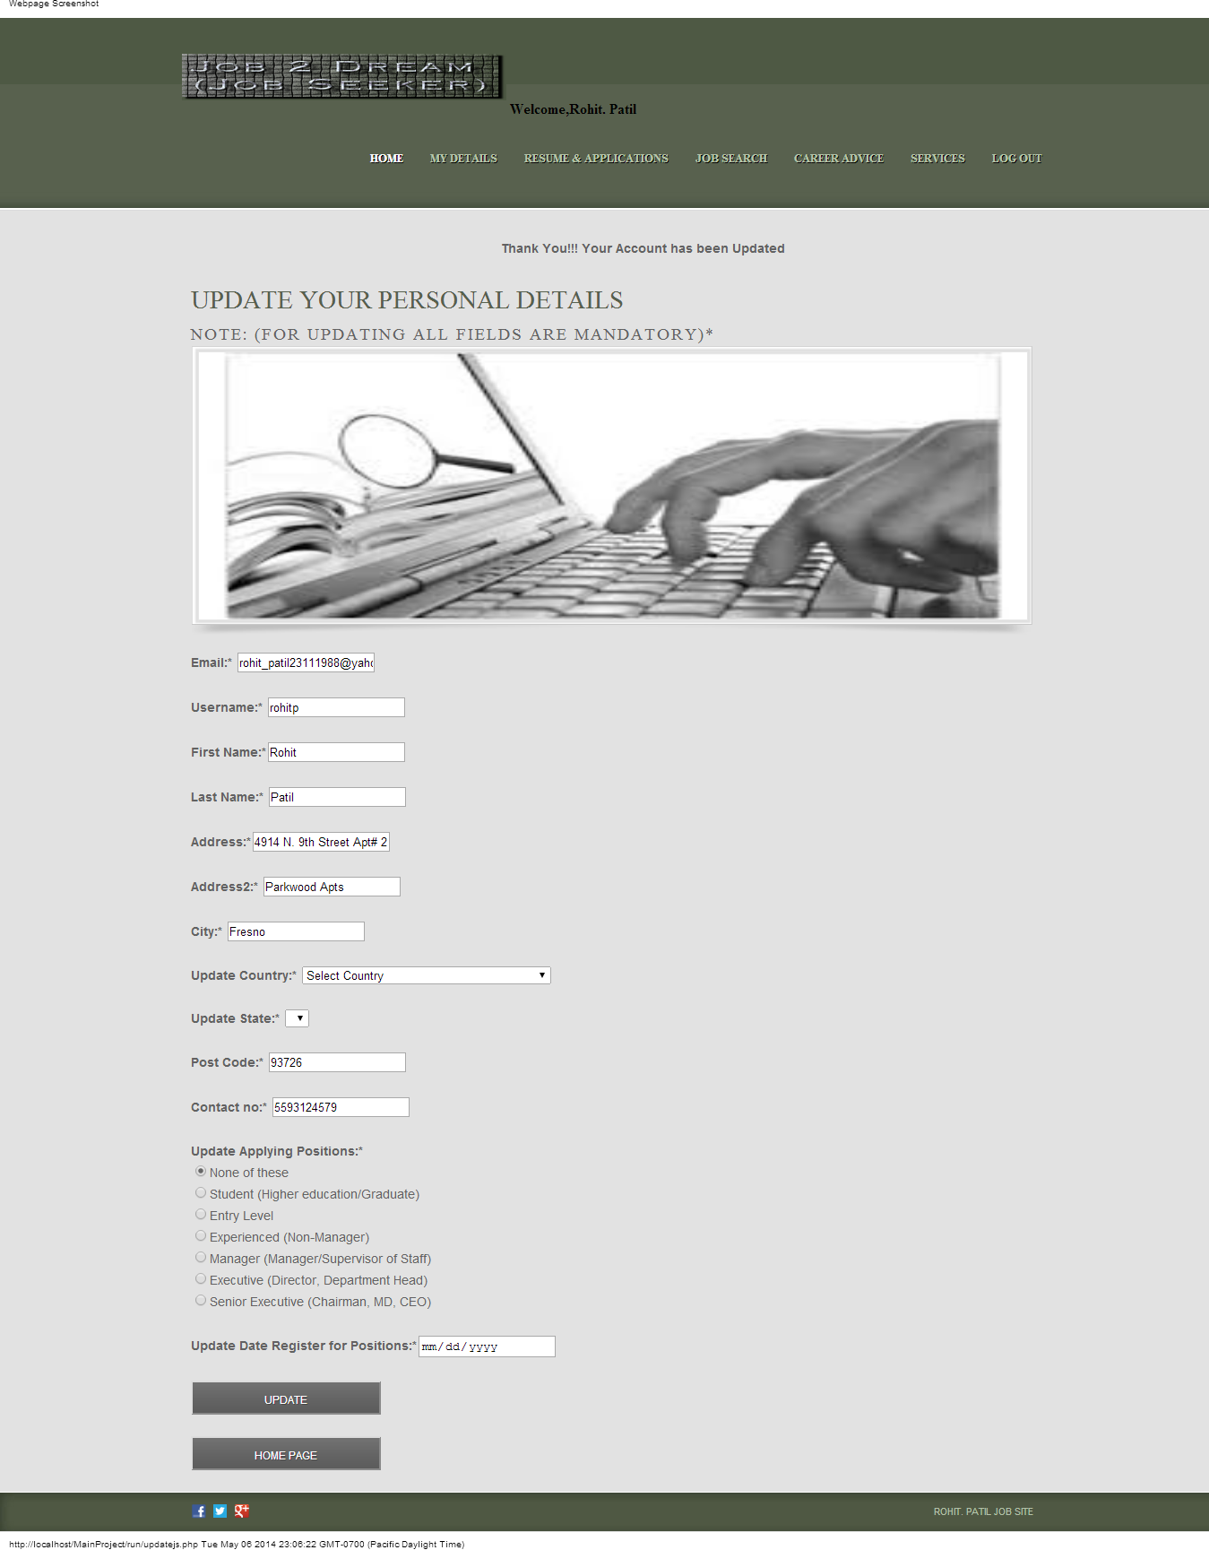

**Registering CV/Resume:**

This section is used by Job Seekers to register the CV/Resume under the desired job categories and under job vacancies with notification message of successful submission. It has the feature to upload the Resume and saving it in the directory and after Uploading the Resume the User gets the link through which he can download the CV/Resume as and when required.

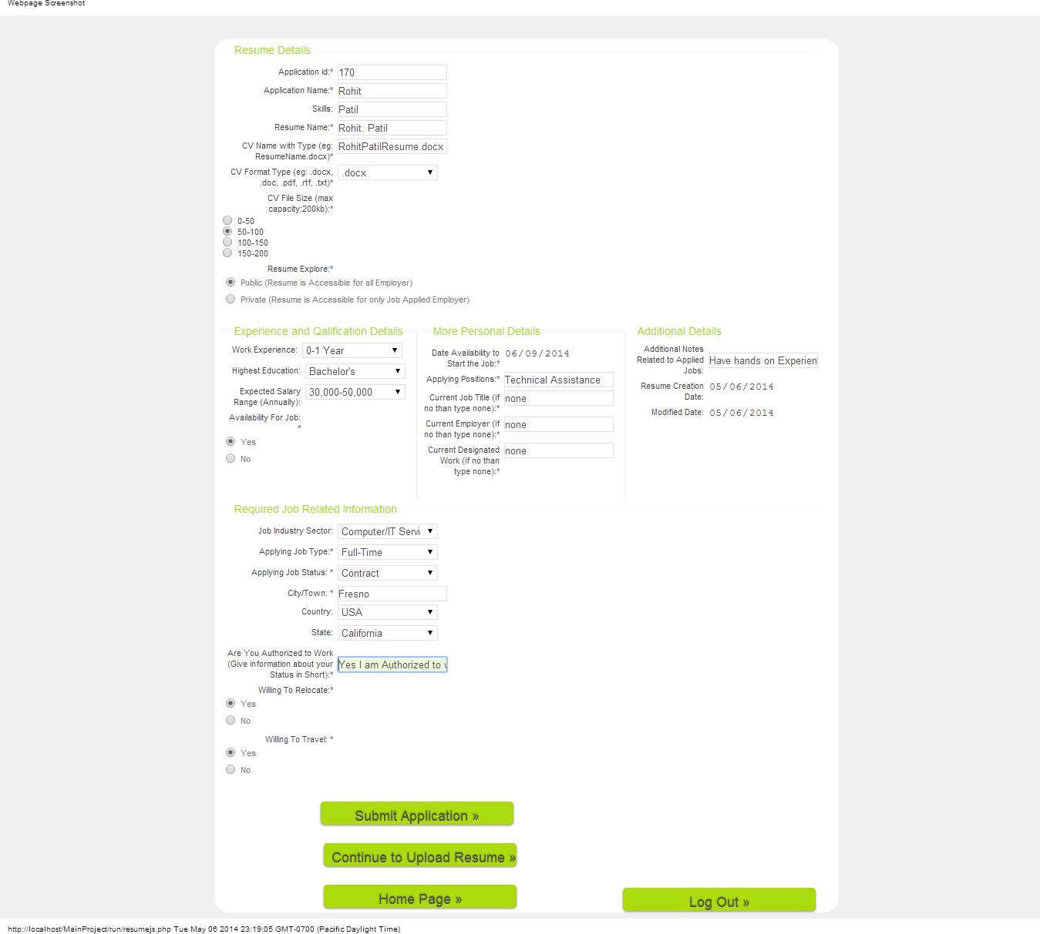

Above form is used to fill in Resume details after filling the details when the user submits the application he gets the notification message of successful submission of the Resume like below

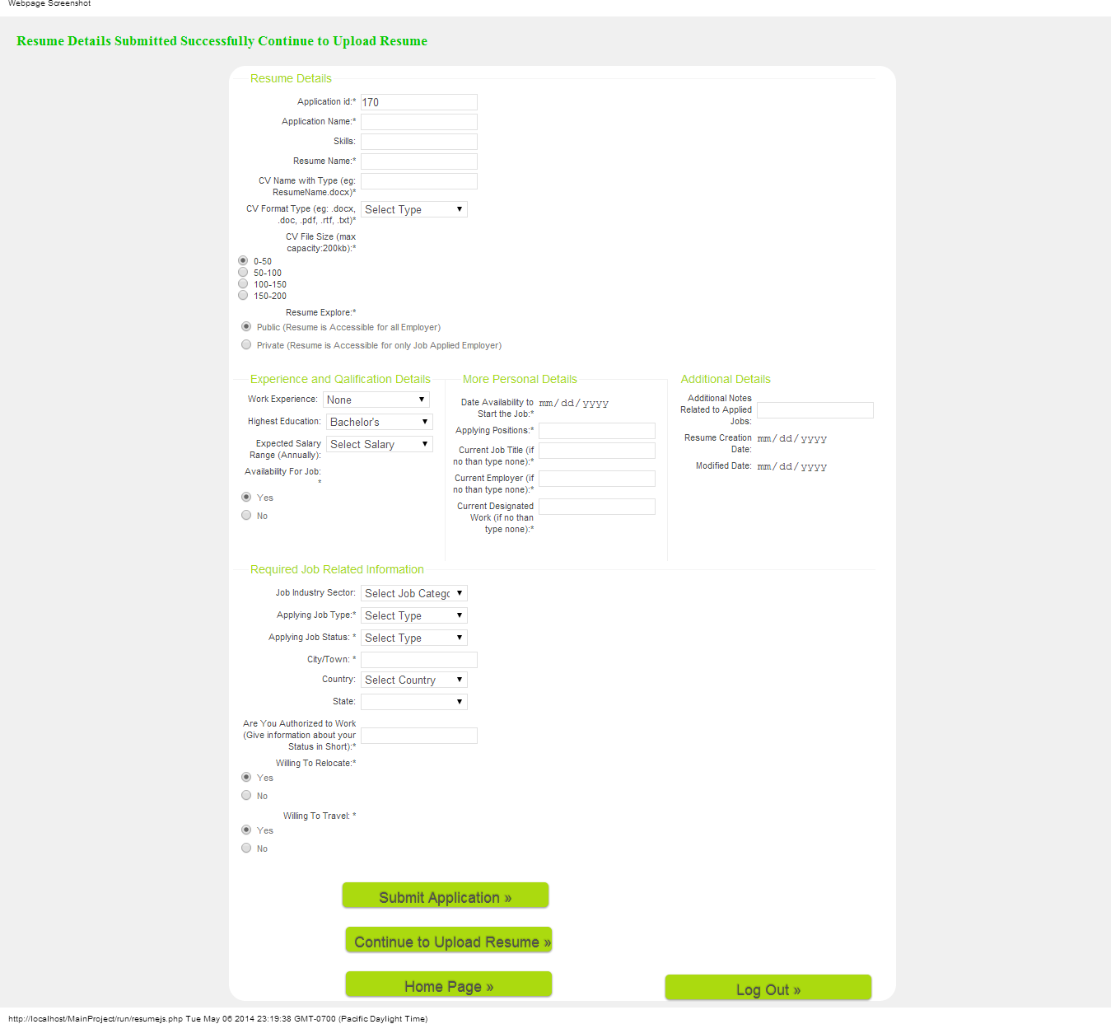

After posting the above Resume Details successfully the user can continue to upload his resume to the Job site.

Below is the form for uploading resume: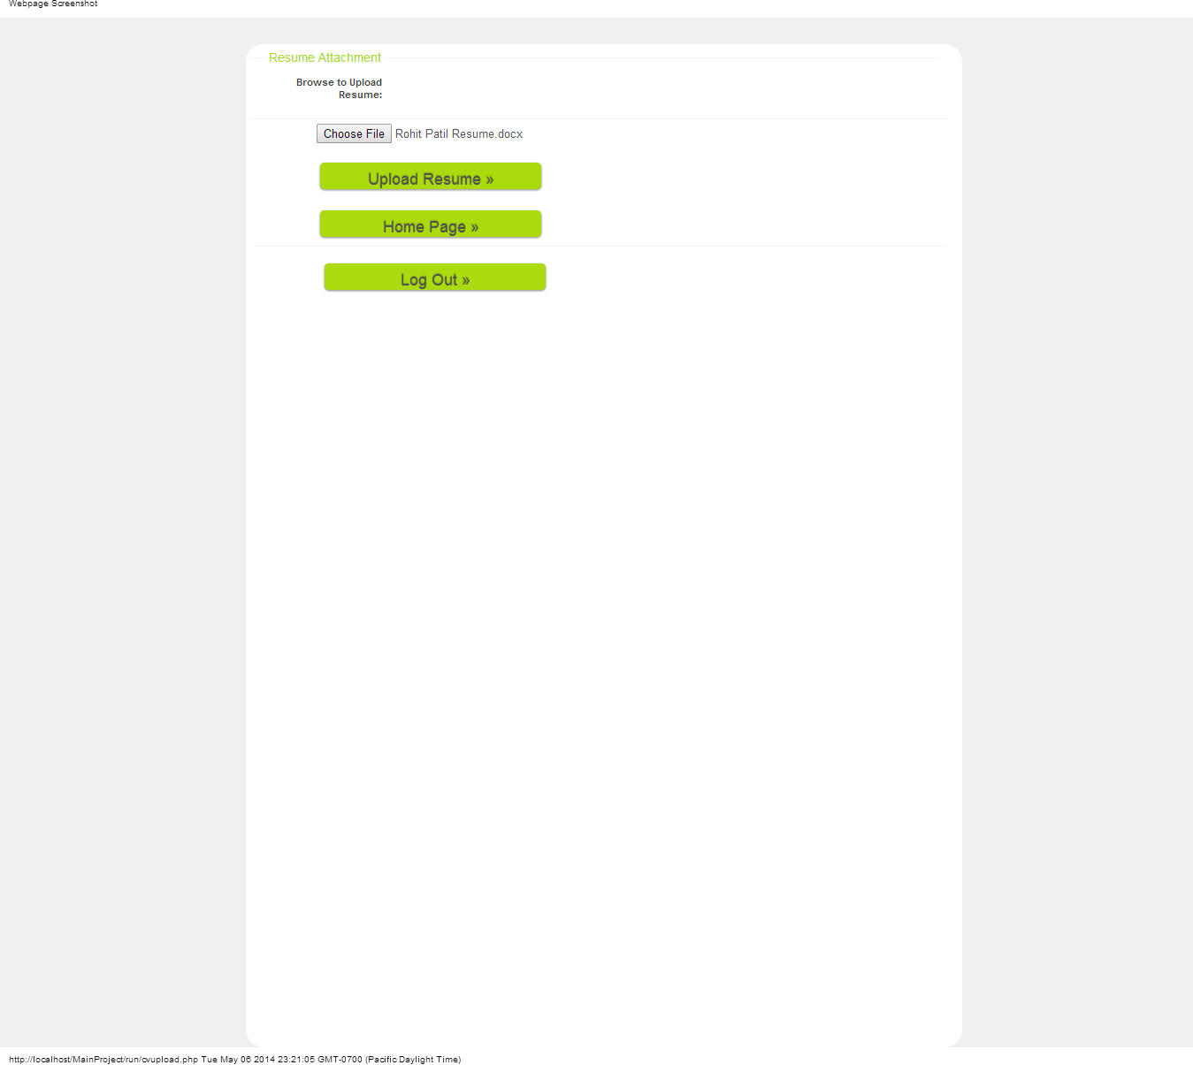

After Uploading the Resume when the clicks on the upload Resume button the Resume gets uploaded to the Job Site directory and the User gets the message accordingly.

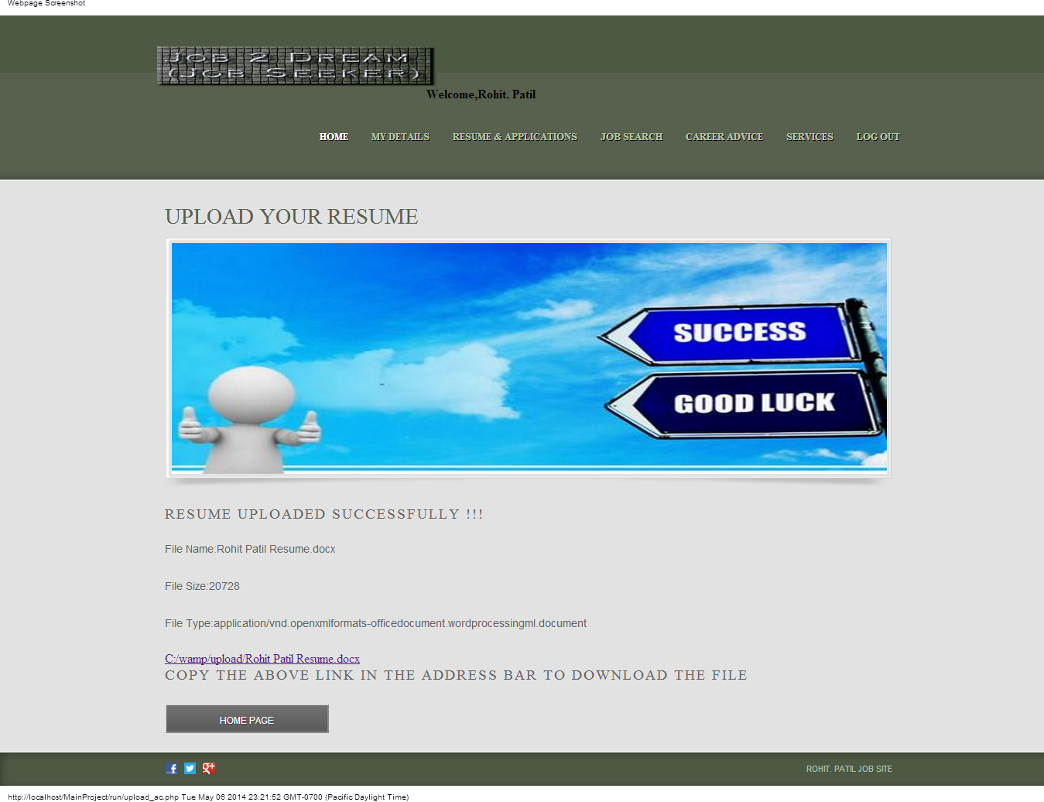

The user gets the above prompted message after he uploads his resume with the download link for downloading his resume for later use.

**Searching Job according to skill set and Category Section:**

Job Search section designed for Job Seeker makes him to search the Job according to his skill set. He can search the Job my mentioning the keywords or selecting different Job categories.

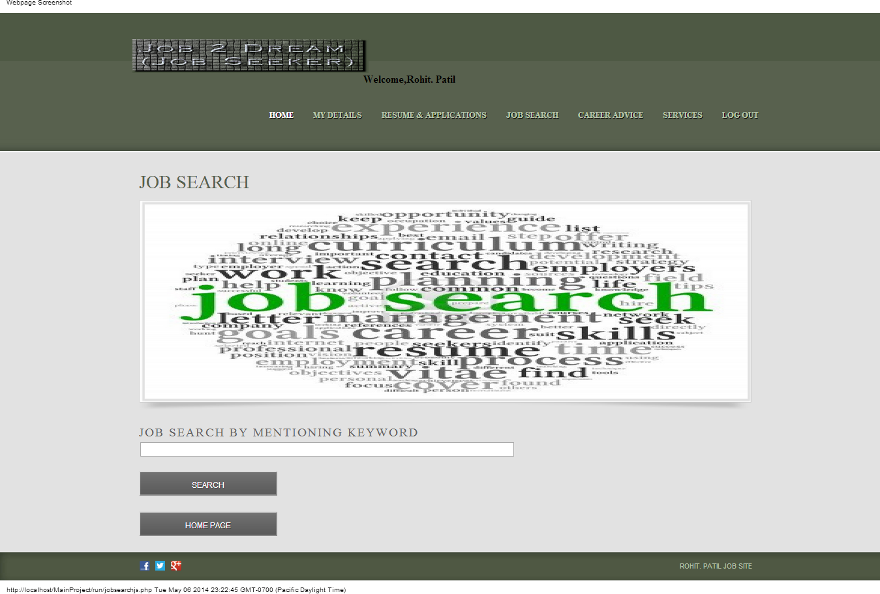

Above form is used to search the Job by mentioning the keywords according to skill sets.

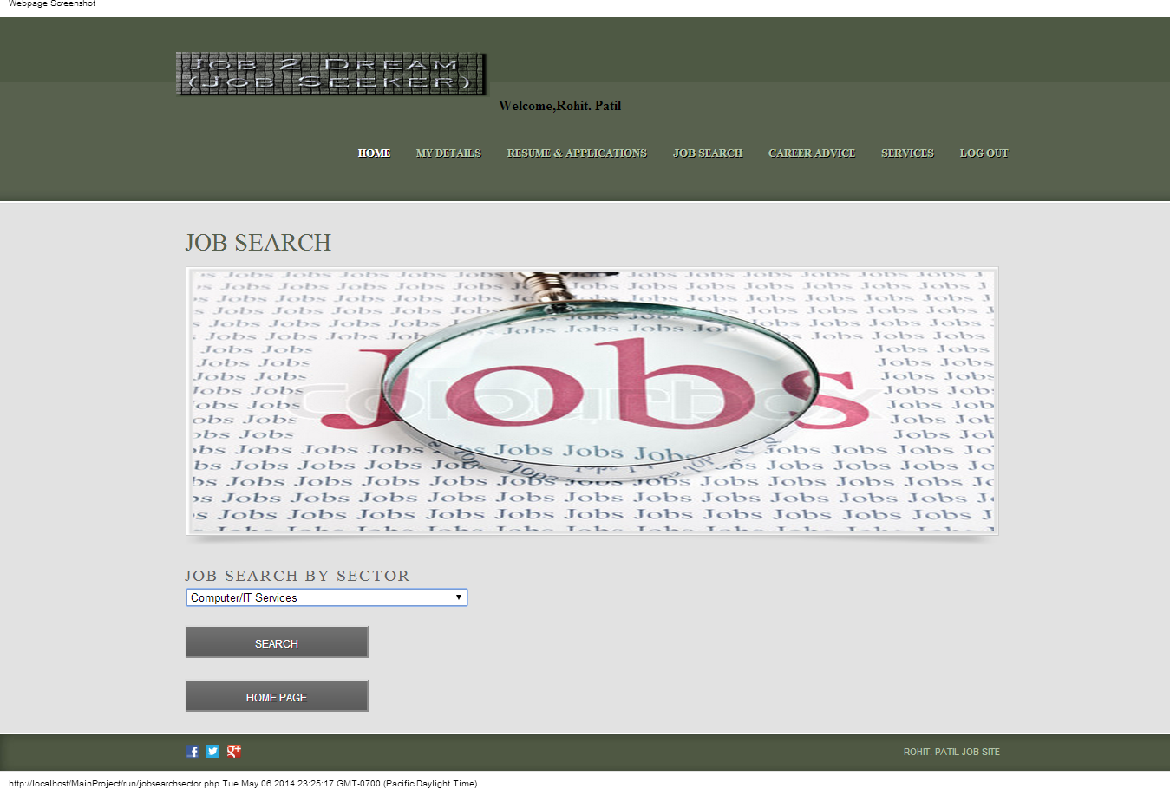

Above form is used to search the Job according to the Job Categories.

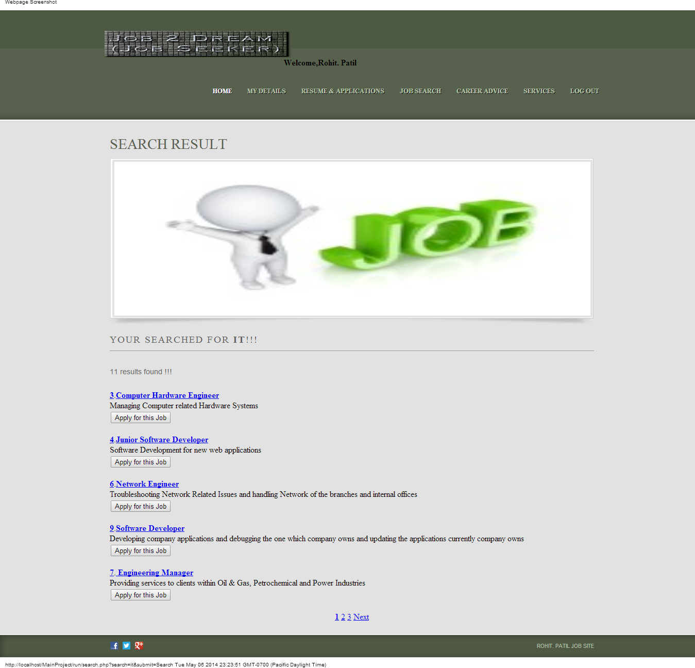

When the user searches the Job by either or the way by mentioning the keywords, skill sets or by the category he gets the above result page through which he can see the list of the employers who has posted the Jobs.

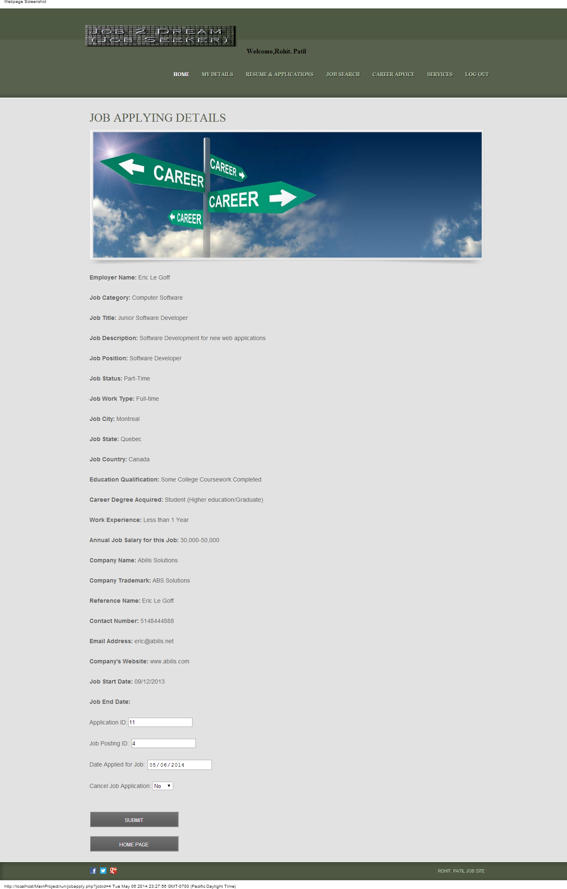

After the Job Seeker selects the desired Job Provider (Employer) he gets directed to the above form to apply for the posted Job by the particular Job Provider.

When the Job Seeker successfully applies to the Job he gets the prompted message like this below:

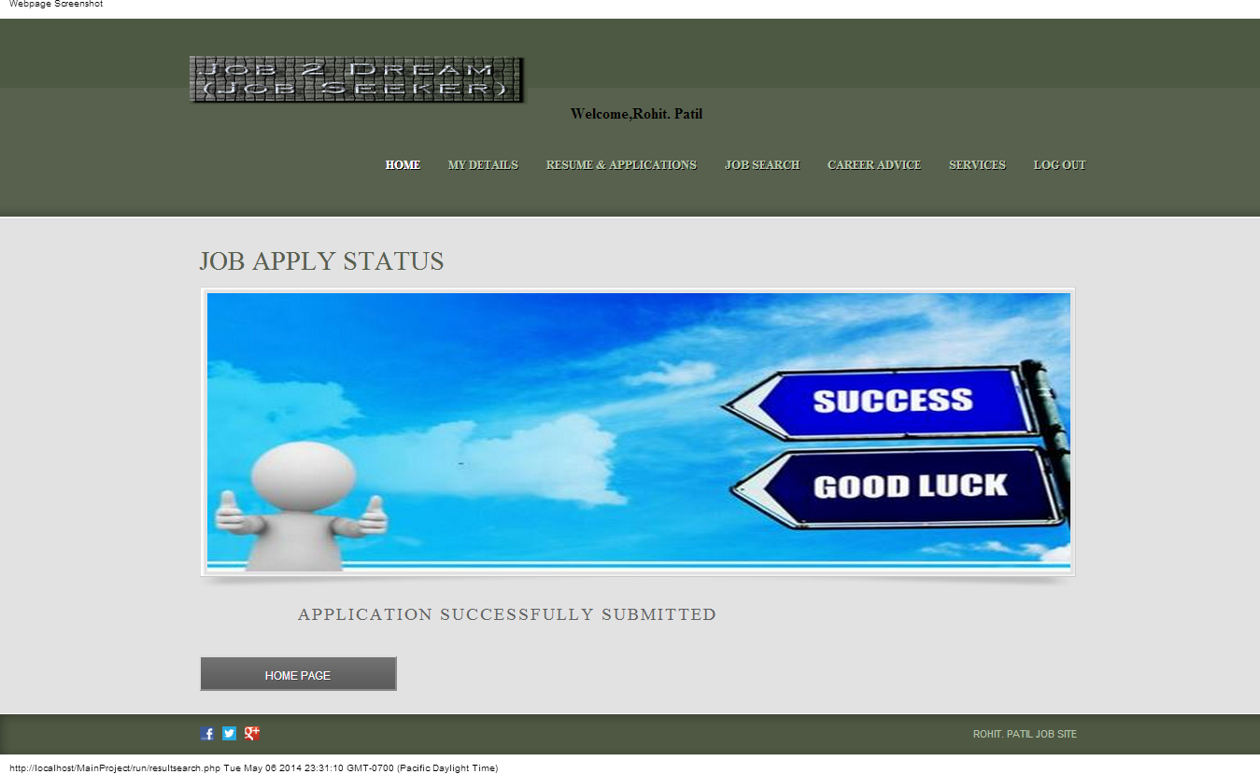

**Career Advice Section:**

Career Advice section is designed for Job Seekers benefits through which the Job Seeker can utilize certain helpful tools and feature which provides Job Seeker with an easy way to learn tips for posting Jobs or Resume under different Job vacancies and several many other features.

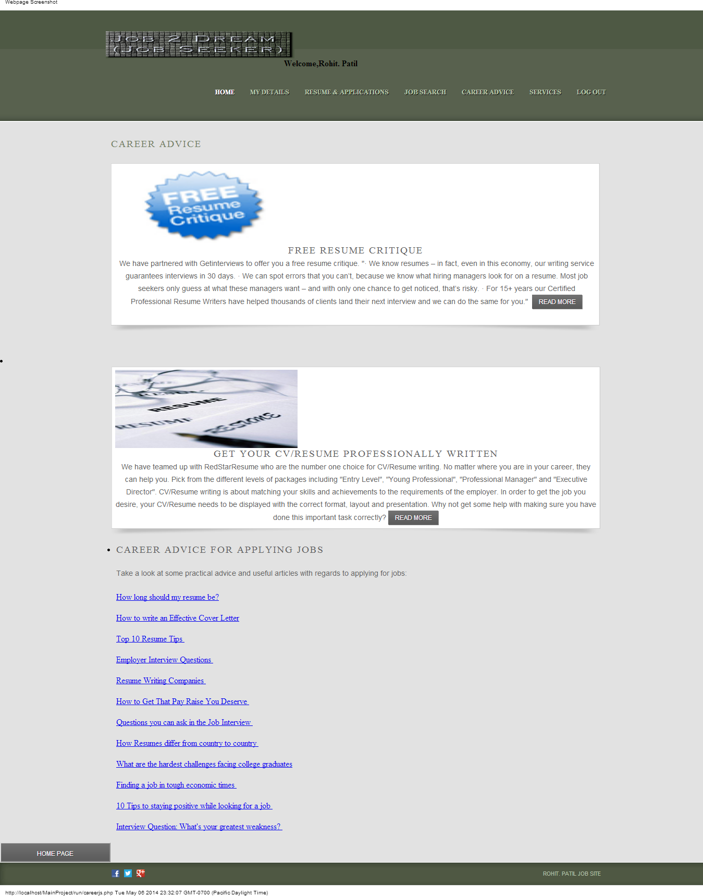Above page is used as helpful tools for several features related for Resume writing, Job Applying, etc.

**Services Section:**

Services Section is used for Training and Education for Job Seeker through which the Job Seeker can learn many new things related to the new Job search techniques and many more new learning websites which will be helpful for uplifting their own career. Below is the form for the services section for the Job Seekers.

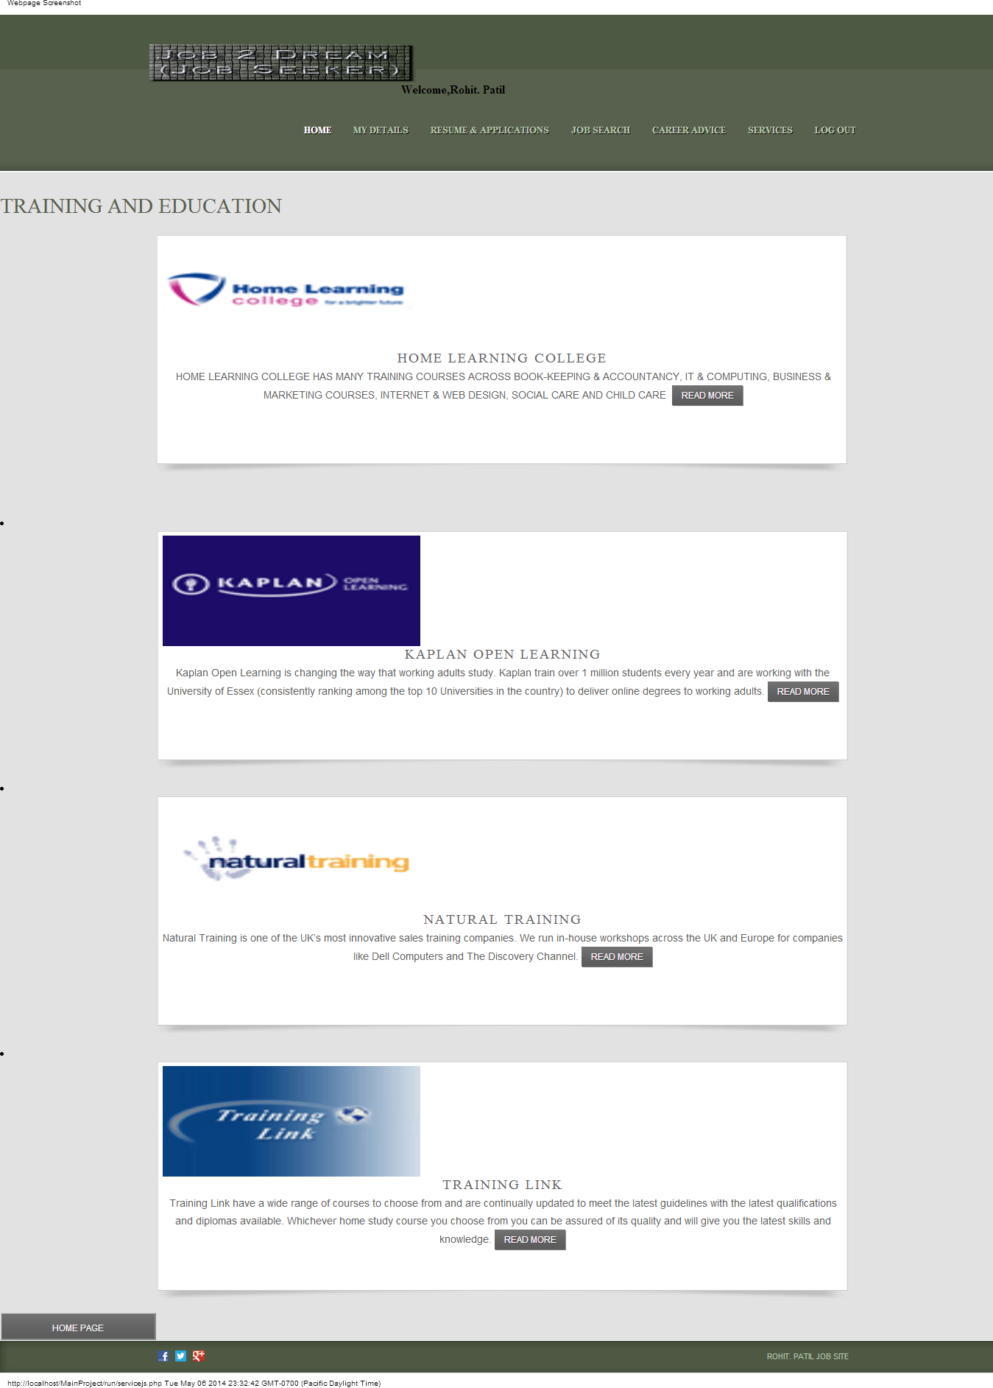

## Job Provider Section:

Job Provider Section consists of modules like:

* Job Provider Registration
* Forgot Password
* Login Job Provider
* Homepage for Job Provider
* Account Details (Update Feature)
* My Jobs consisting of (Advertising a Job, View Advertised Jobs, View Job Applications)
* Search for Resumes
* Recruiter Resources

**Job Provider Registration Section:**

The Job Provider Registration section is designed for registering to the website for using the features of the Posting Job through the website. It consists of registration form through which Job Providers Registers to the website using username and password for the account activation. The Job Provider fills in the details and completes the registration. After submitting registration account activation link is send to the registered Email-ID and with help of the activation the Job Provider gets registered to the Online Recruitment Website. There are certain prompt messages used for notifying user whether there is an error during registration process so the user can fill in the error correctly and can complete the registration easily.

**Features used in Registration form of Job Provider:**

In designing the form the use of Ajax tool and JavaScript is used to prompt the error messages while registering the website. The main feature of it is Username and Email-ID check availability, Email-ID validity and Username strength notification. It fetches the data from the database without loading the page with the help of JavaScript and Ajax Toolkit to check whether the Username and Email-ID is available or not and prompts the error message accordingly. It also has features like automatic loading of State Province for its Related Country. This feature helps to easy load of state instead of searching through wide list

Below is the Job Provider Registration Form Snapshot with its prompt messages used: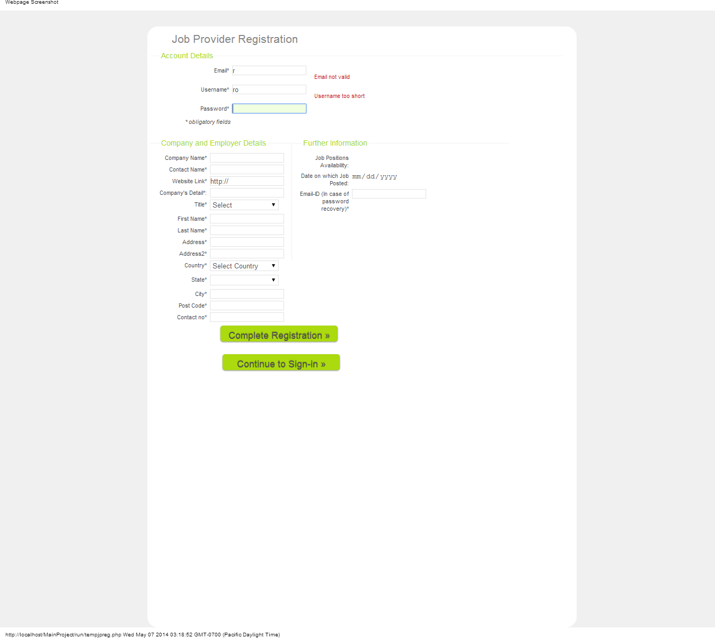

The above form states the Email-ID validity and Username Strength message.

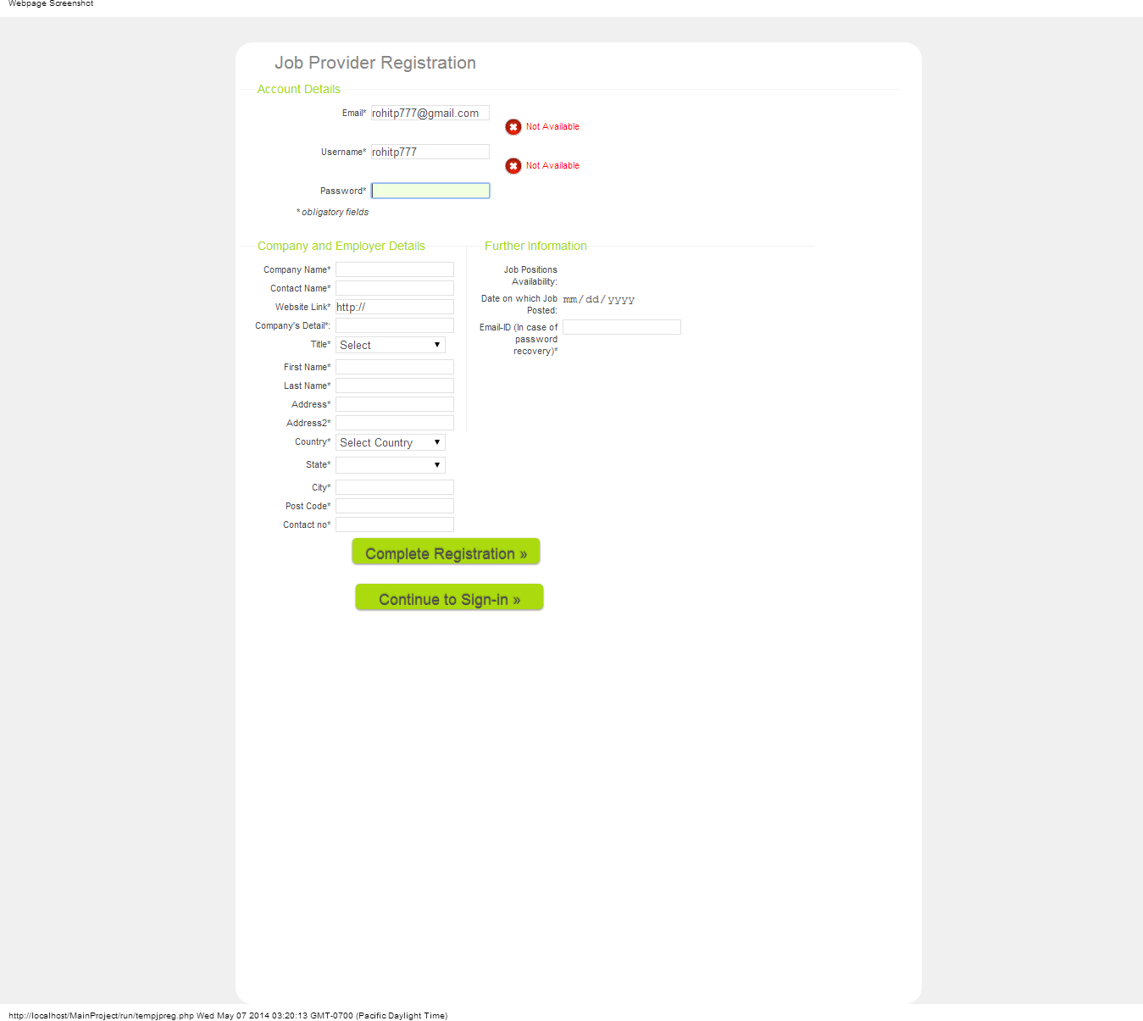

The above form prompts the error message of Email-ID and Username Availability.

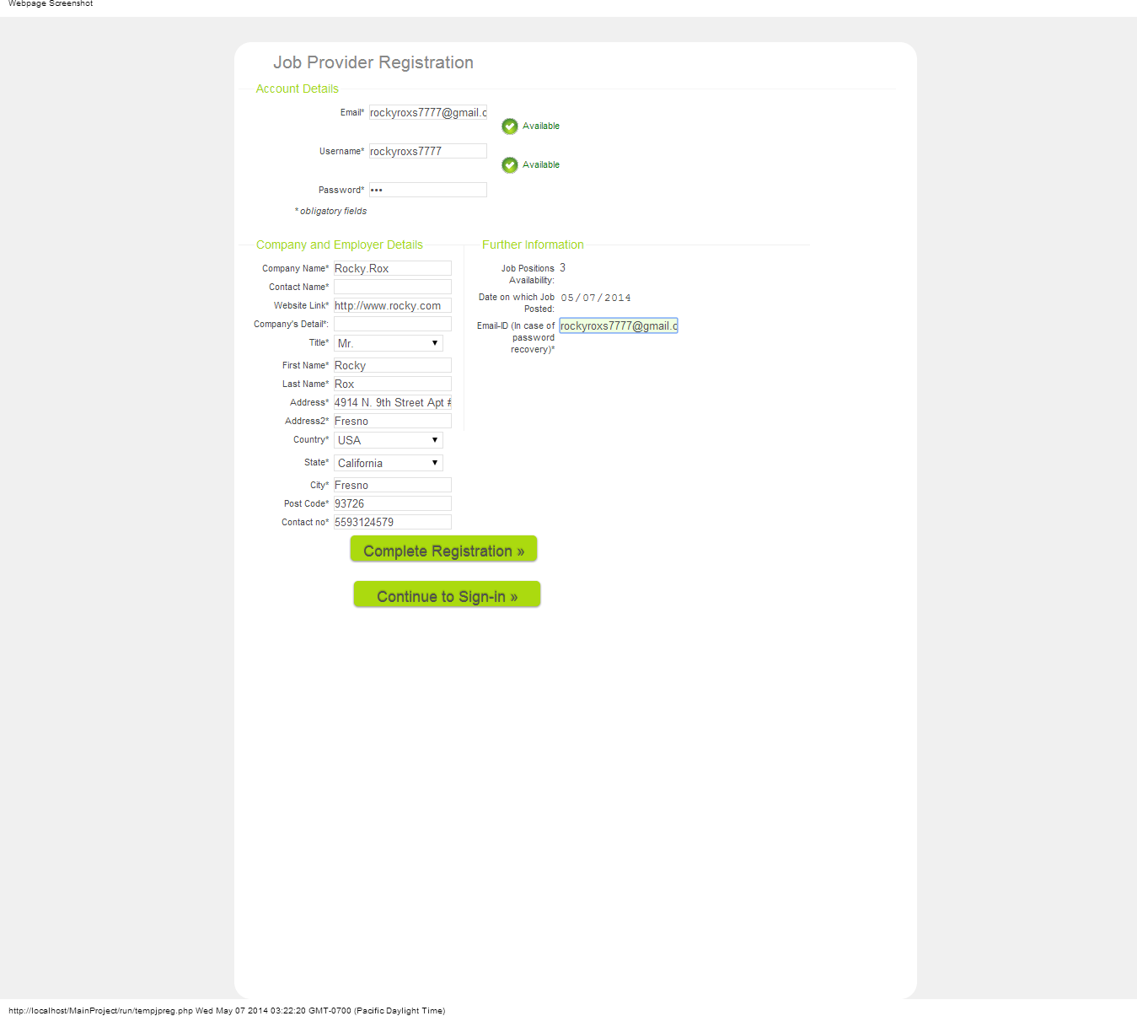

The above form prompts the username and password available message.



The above form is the completed Registration Form for Job Provider Profile.

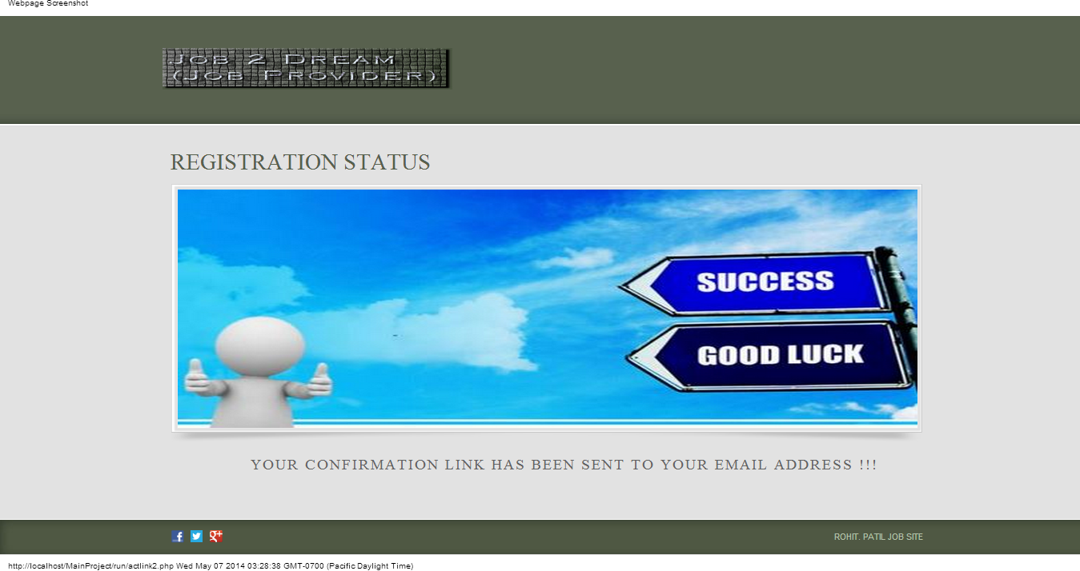

Above form is used to show the message for the Job Provider that the Registration is complete and the confirmation activation link is send to the registered Email-ID.

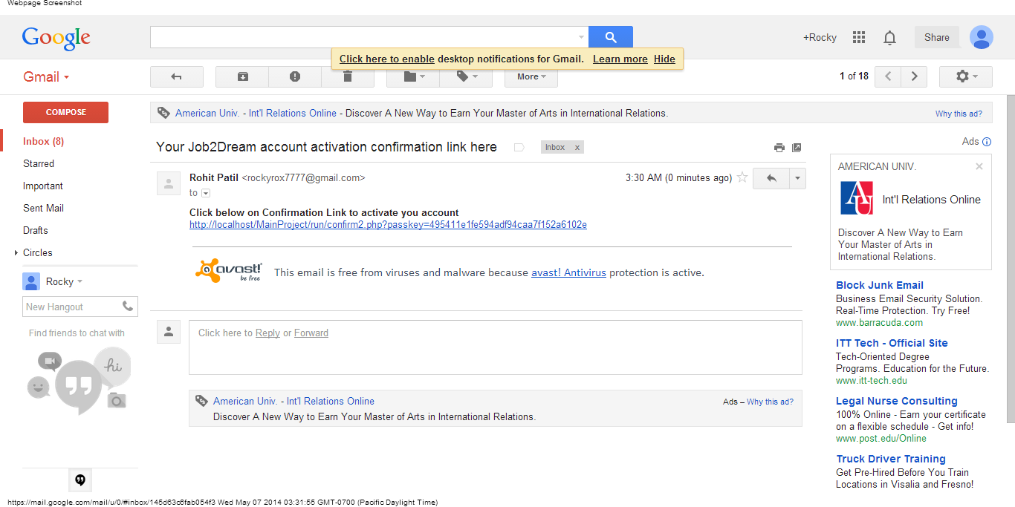

After Registering the Job Provider gets the account activation link like above in his Email-ID through which after clicking on the link the account gets activated for his Online Job Recruitment Website.

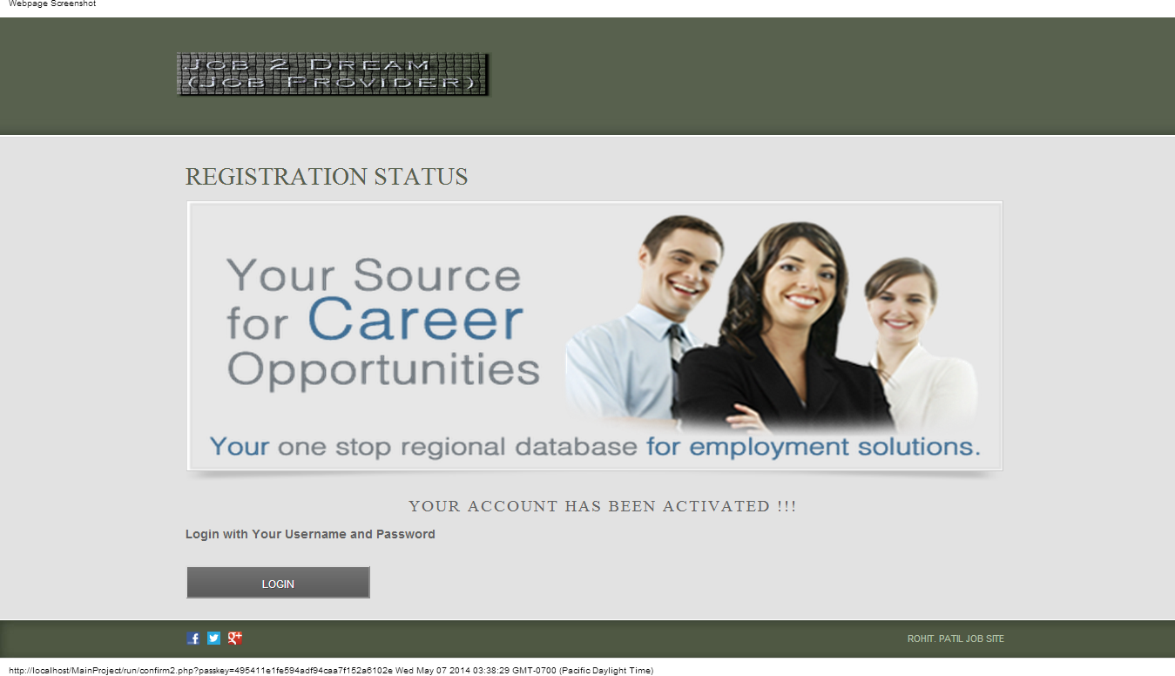

The above form notify the Job Provider that his account is been activated and he can Login through his Username and Password through the Login Button.

**Forgot Password Section:**

This Section is used when the Job Provider forgets his password or wants to update his password. This feature helps him to get his Email-ID and Update password notification link through his registered Email-ID. The Job Provider can update his password by clicking on the link and the prompts messages accordingly help him throughout the process.

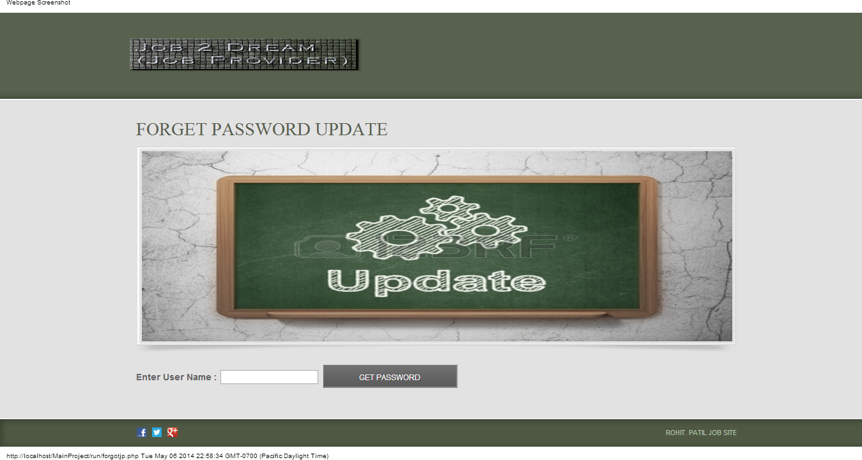

The above form is used to get the password update through the registered Email-ID by inputting the username field.

After completing the username field the user gets Email regarding updating the password link.

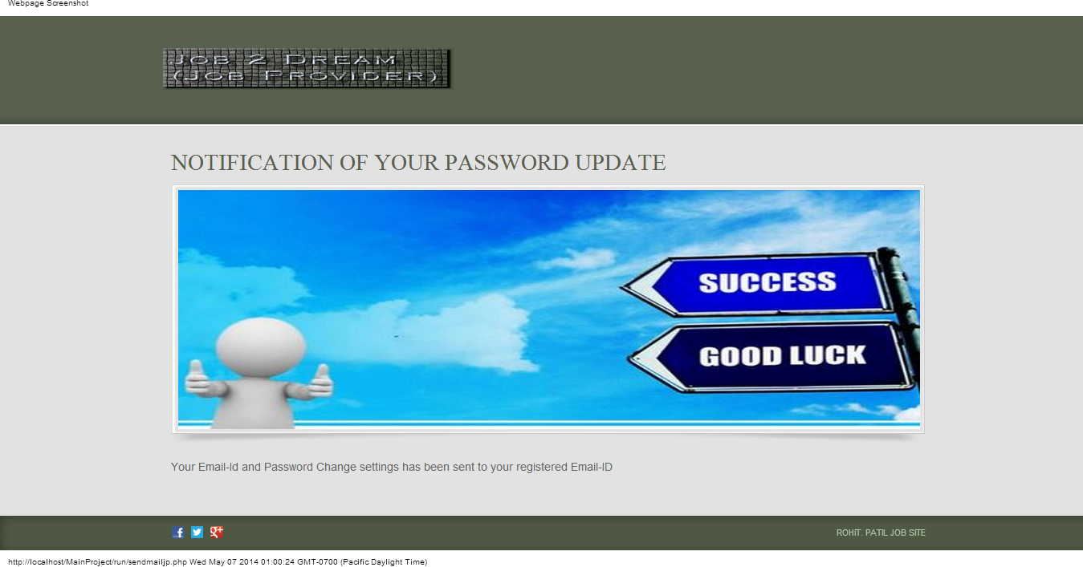

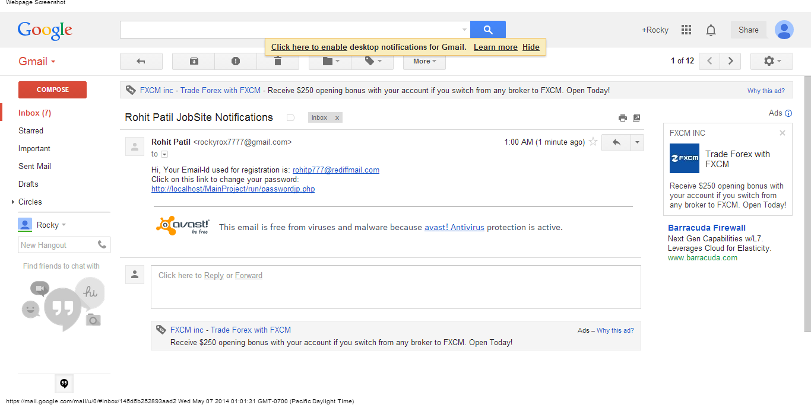

The Job Provider gets the Email notification with the password update link and the Email-ID used during the registration.

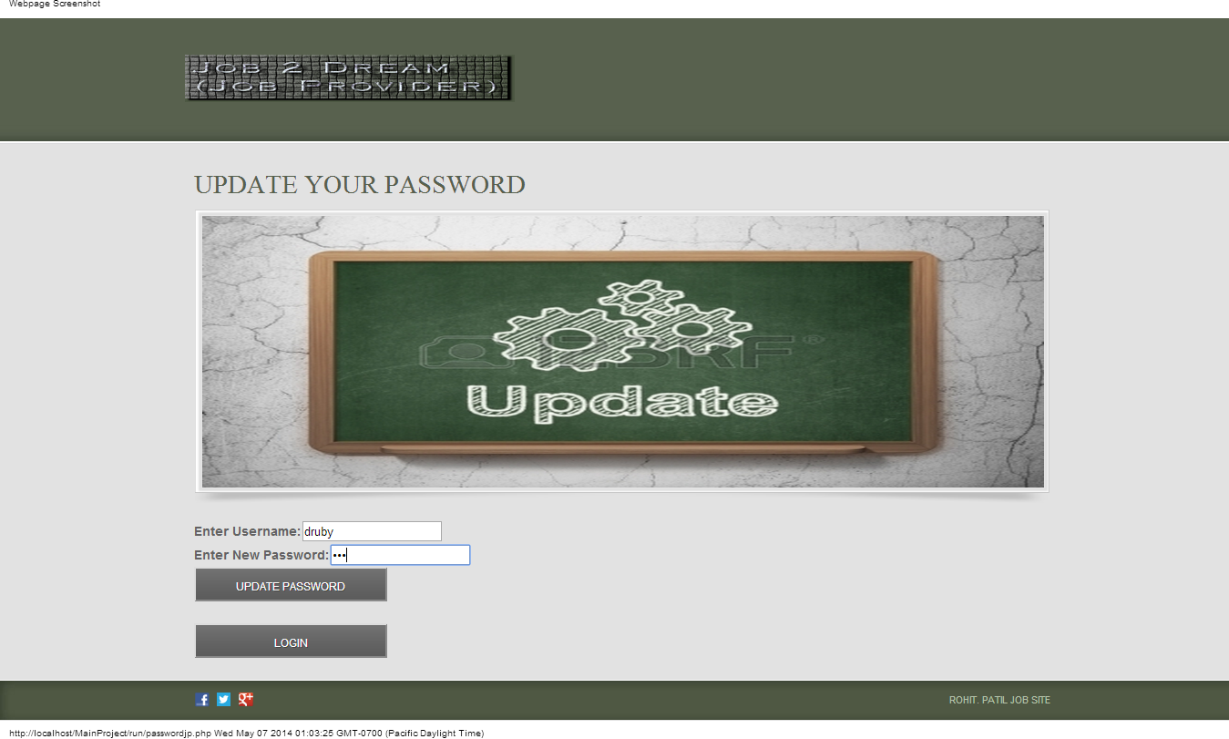

After clicking on the link for updating password through the Email-ID the link gets directed to the above form through which the user can update password easily.

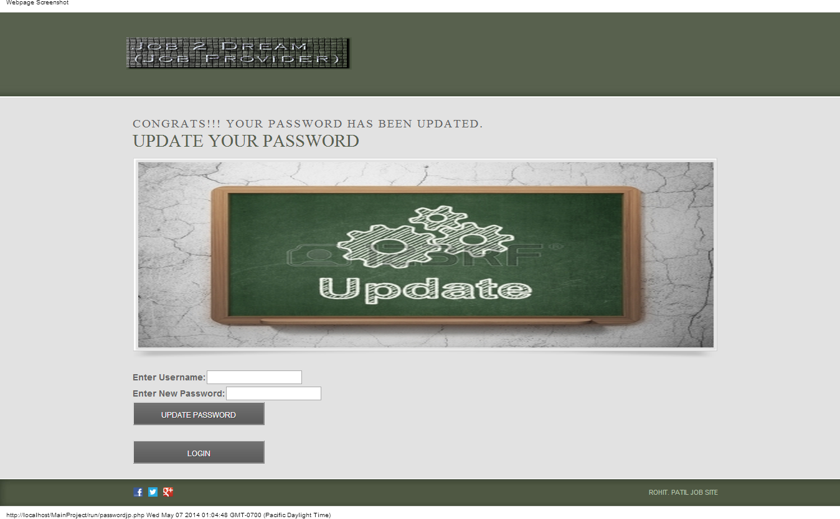

After filling in the details in the above form the password gets updated and the user gets the notification message accordingly.

**Login Job Provider:**

The Login Job Provider Section enables the registered Job Provider to Login into his account. The form is designed in such a way that the registered user gets an error message for Login if the Job Provider by mistakenly inputs the wrong username or password and redirects the user to the error Login page. This makes user notified that he might inputted wrong username or password.

Below is the Login form for the Job Provider:

Below is the Error Login Form for the Job Provider:

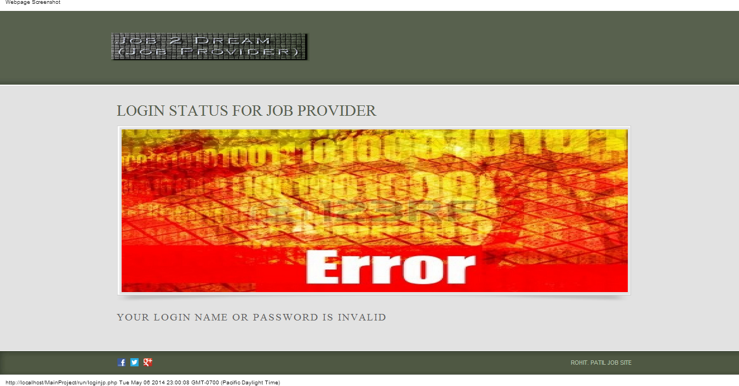

**Homepage for Job Provider:**

It is the main page for the Job Provider through which his entire account is connected. This is the page through which the Job Provider can navigate through different page related to his account. Below is the navigation list for the Job Provider Homepage:

* Home is the index page for the Job Provider
* My Details which has navigation links to My Account Details and Update Password
* My Jobs has navigational links to Advertise Job, View the Advertised Jobs and View Job Applications
* Search for Resumes through which the Job Provider can search resumes
* Recruiter Resources through which Job Provider can navigate to resources and help for Posting Jobs and Job related News
* Logout through can sign out from his account
* Navigational Link to Facebook, Twitter, Google Plus



The above page is the homepage for the Job Provider Profile. When the Job Provider logs into his account he gets directed to this page with the welcome message notification for his account.

**Account Details Page for Job Provider:**

The account details page gives the user his account details used while registering to the website he can update this information as and whenever needed. There is a feature to save the page to the .pdf format also so that the user can use this details whenever required.

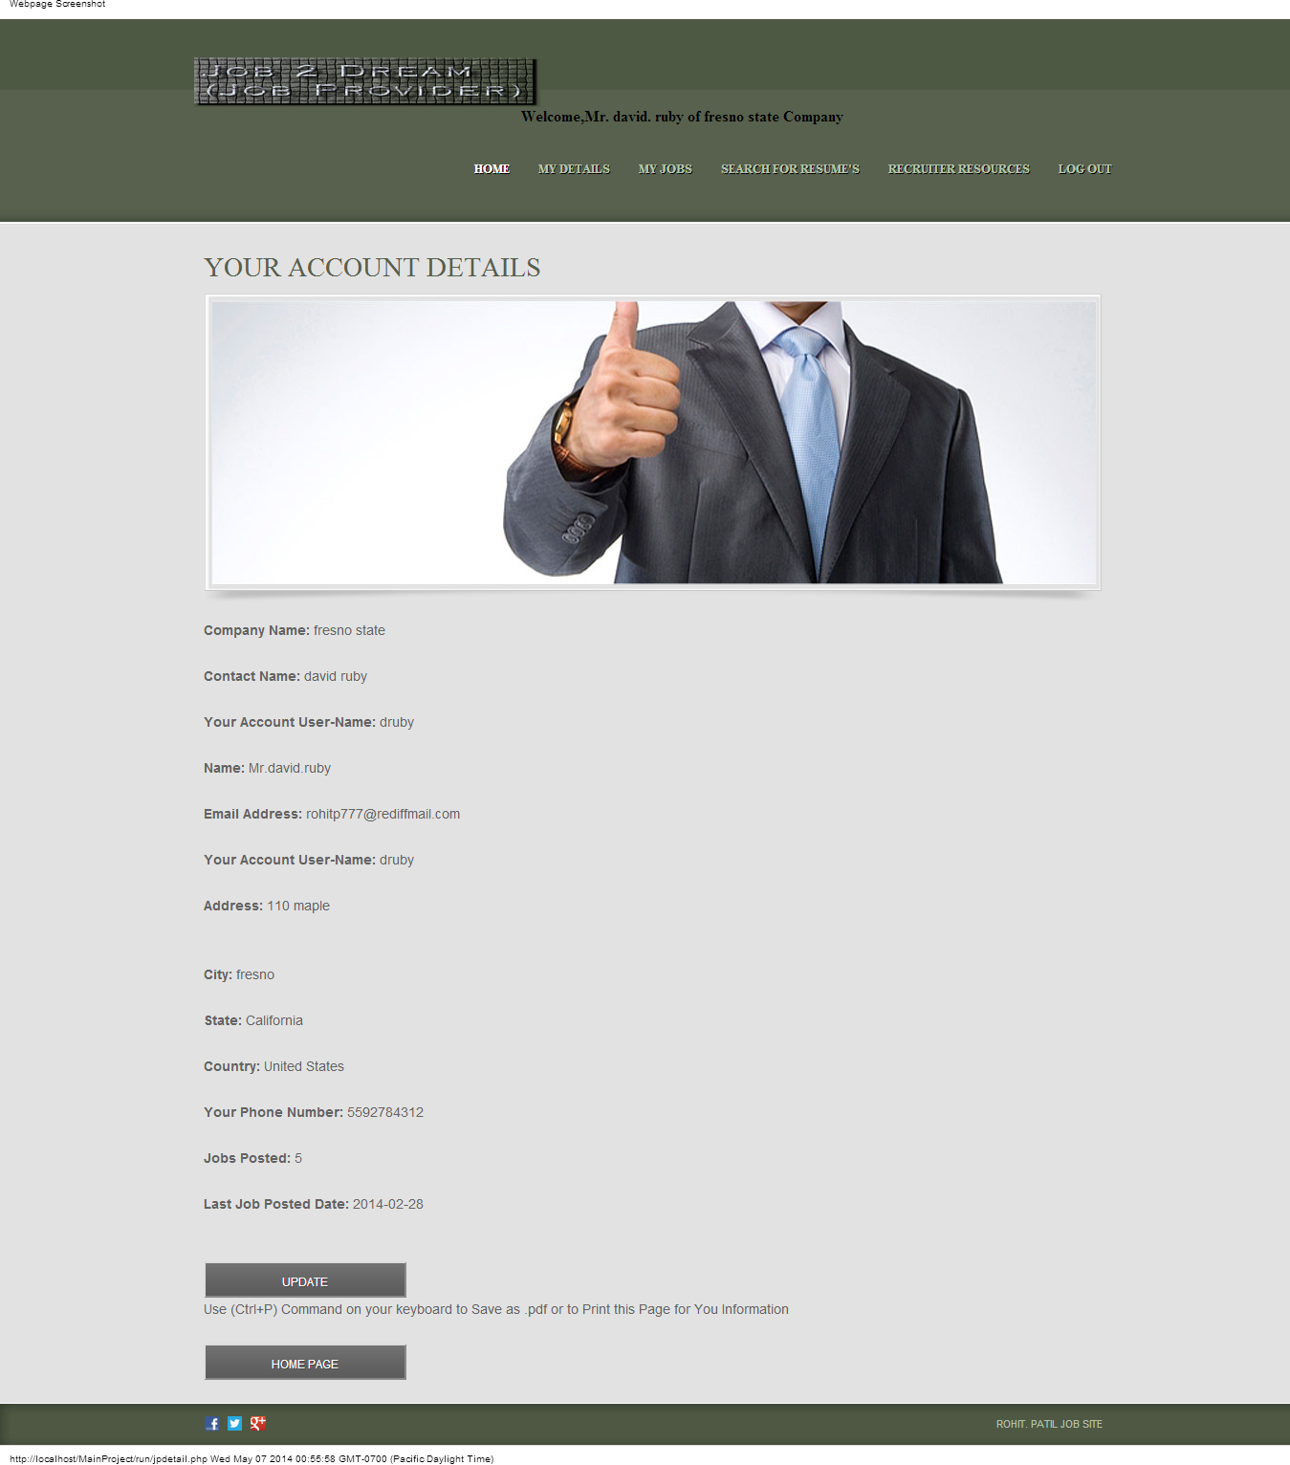

The above form is the account details form for the Job Provider. The user can update his personal information through Update button whenever need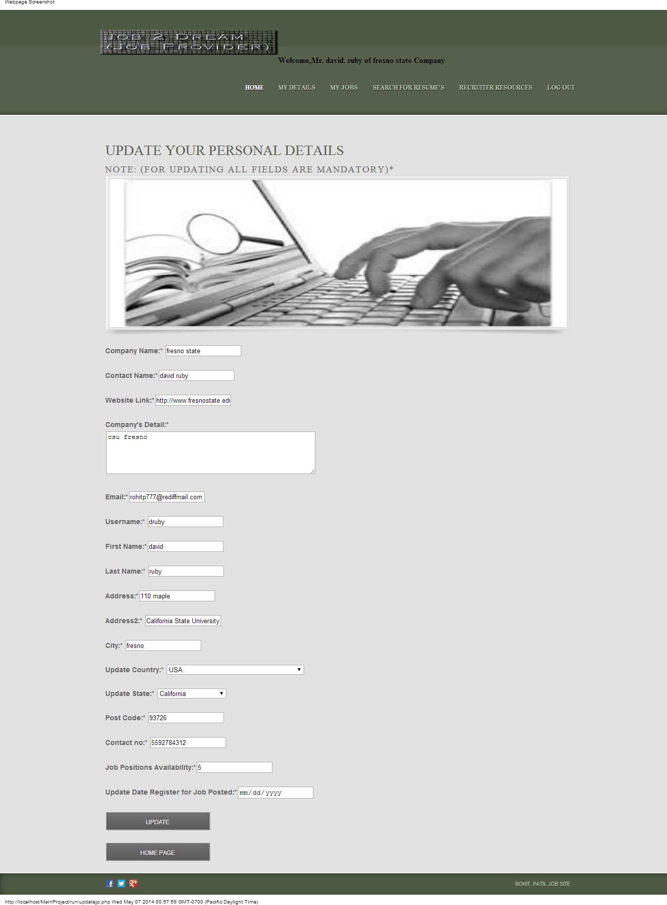

After the user inputs the updated data and clicks on the Update button the account details concerning his accounts gets updated and the user gets a prompt message like below. 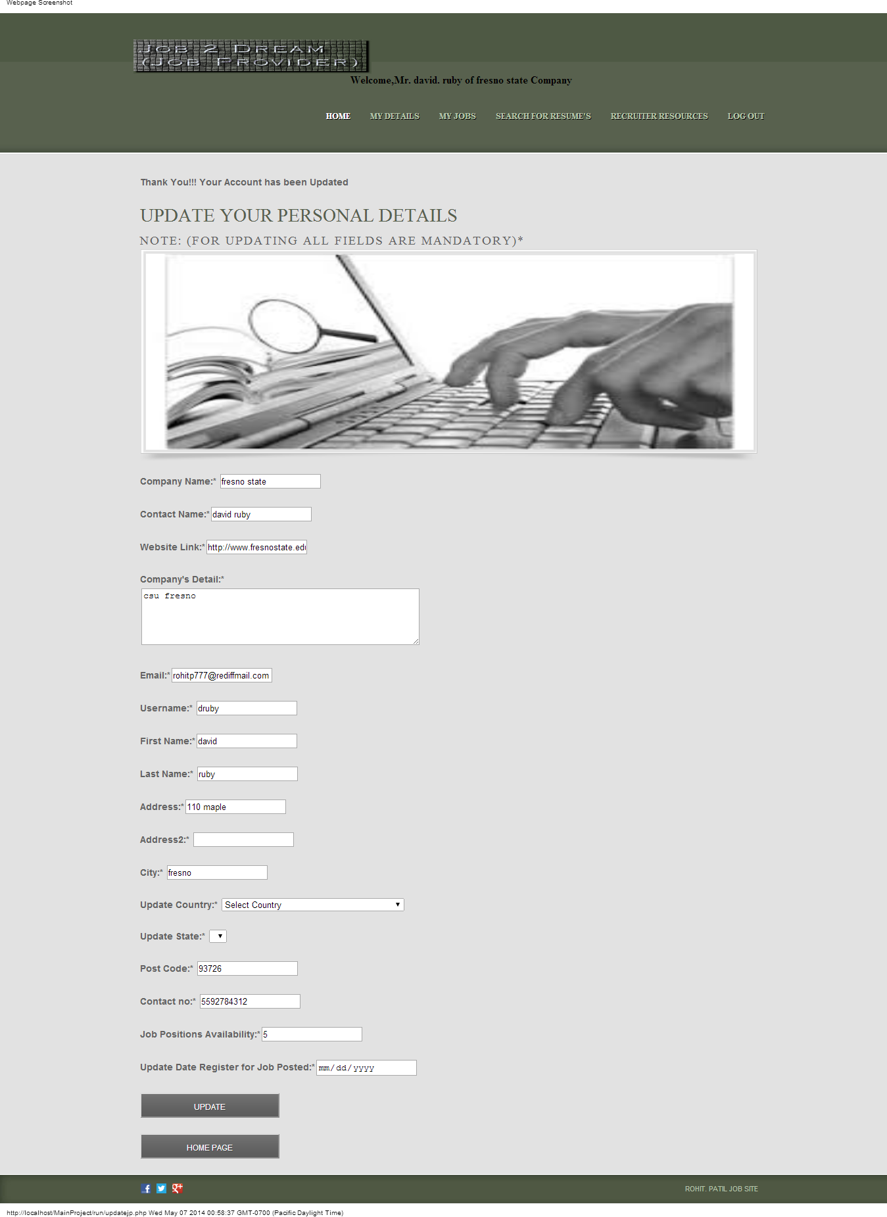

**Advertise a Job:**

This section is used by the Job Provider to Advertise a Job for Job Seekers which his company has vacancies for or for new Job positions.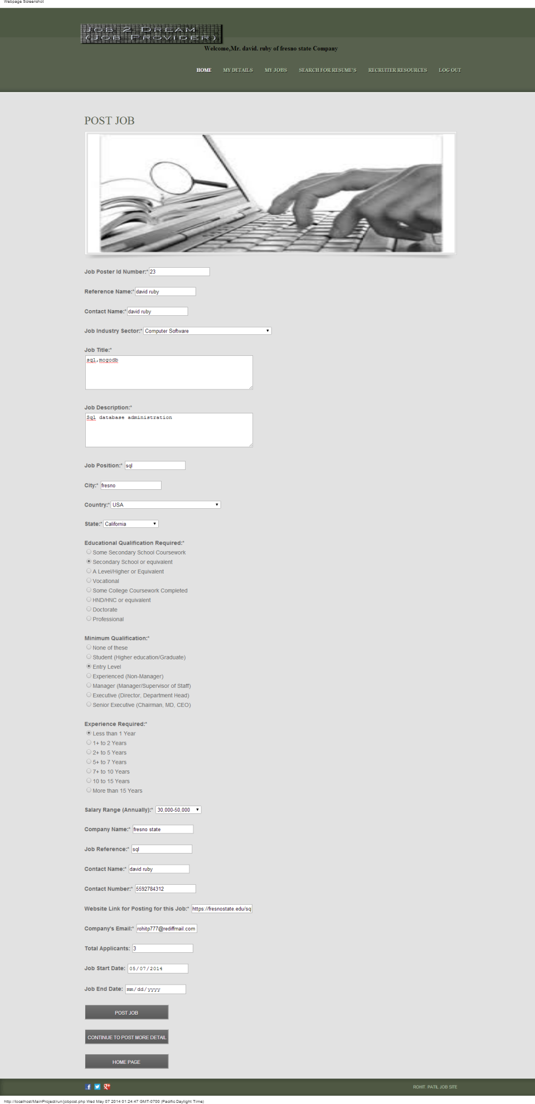

Above form is used for Post Jobs for the Job Seekers. After Successfully Posting the Job the user gets the prompted message for the Job Posted. Below is the result page for the Job Posted

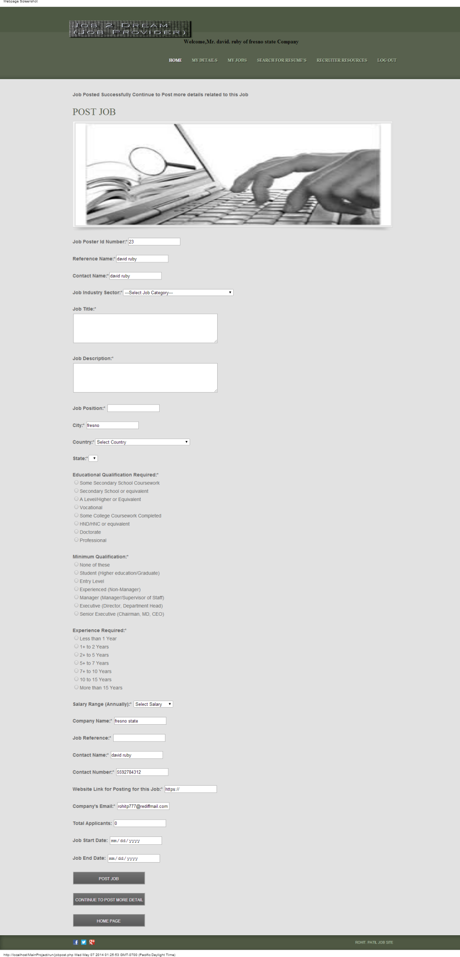

After Posting the Job the Provider continues to post more details related to the Job.

Below form is used to Post the Job Status

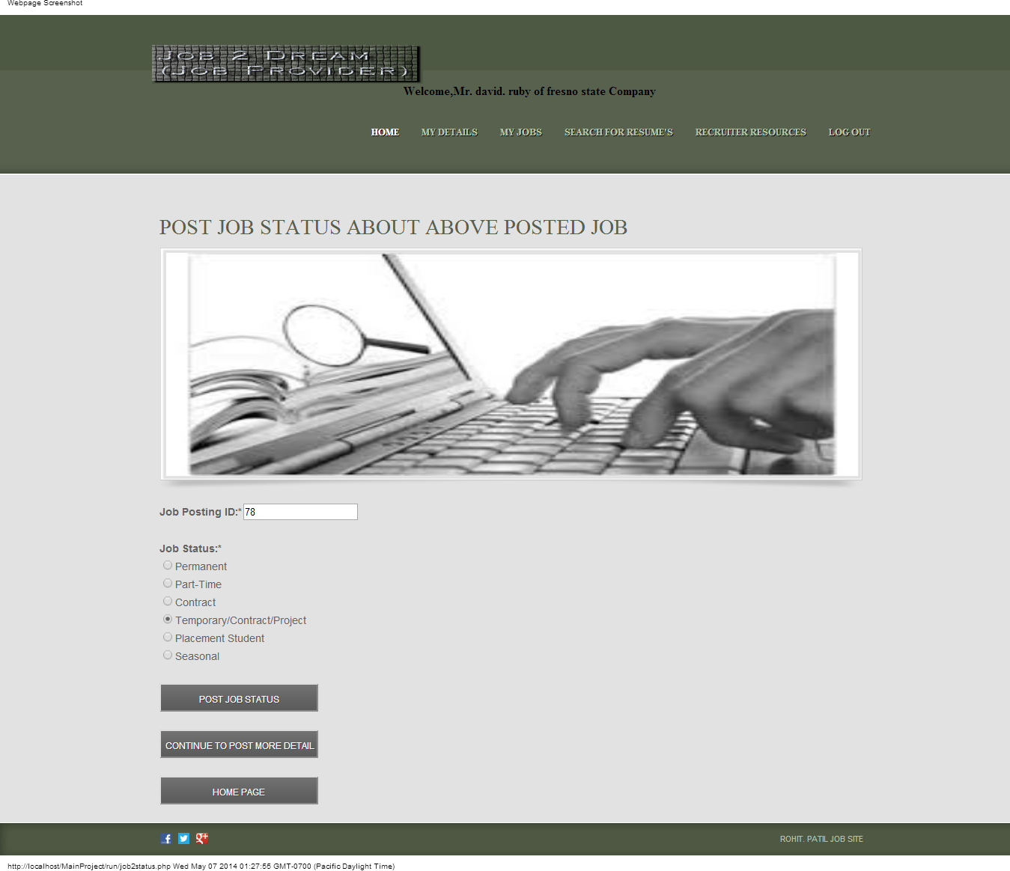After Posting Job Status user gets prompted message for the above Posting.

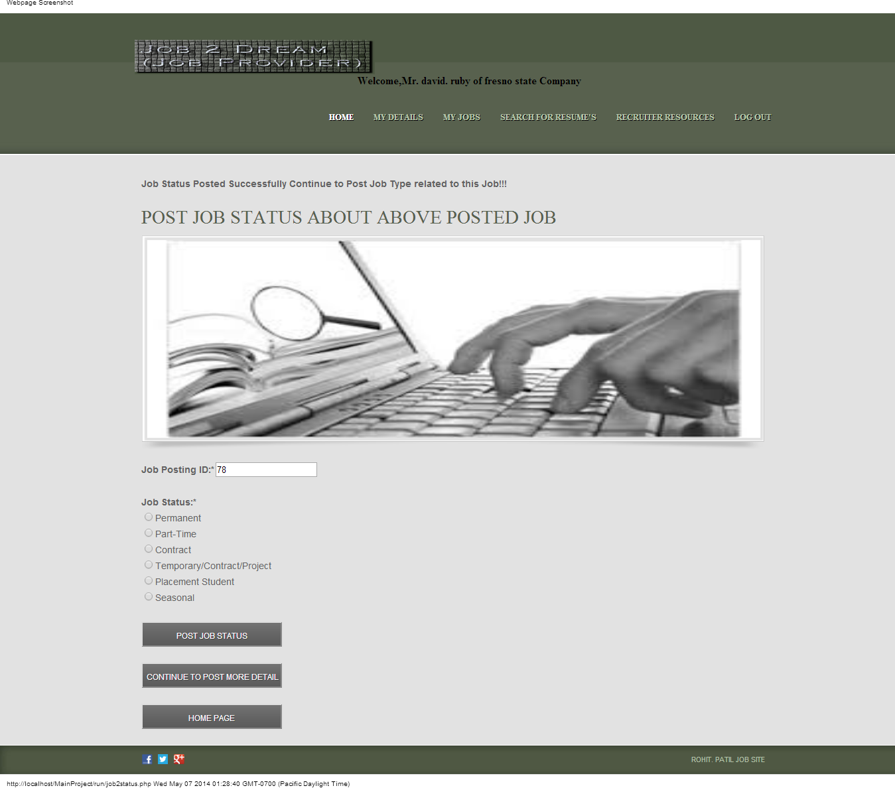

After Posting Job Status Job Provider continues to Post Job Type. Below is the form for Posting Job Type

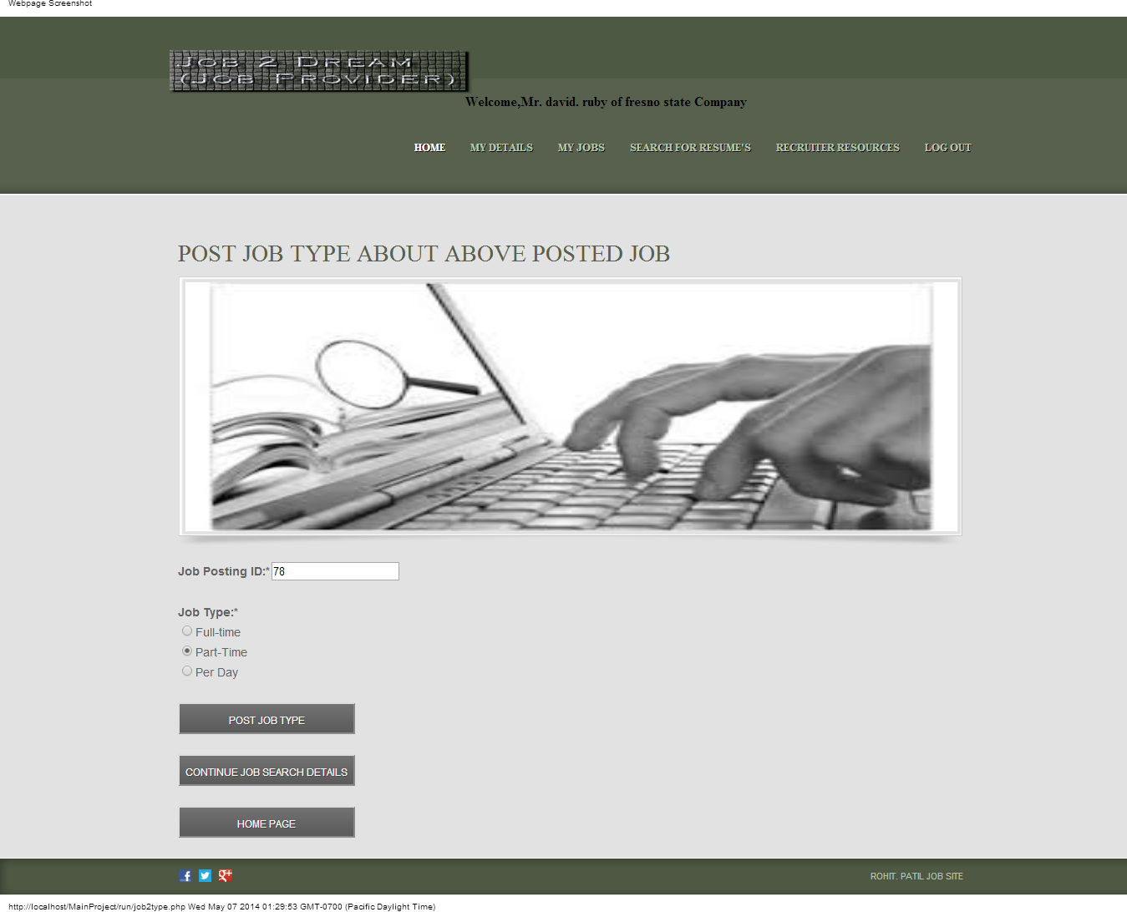

After Posting Job Type Job Provider gets the prompted message for the above Posting

Below is the form for the Job Type Posted

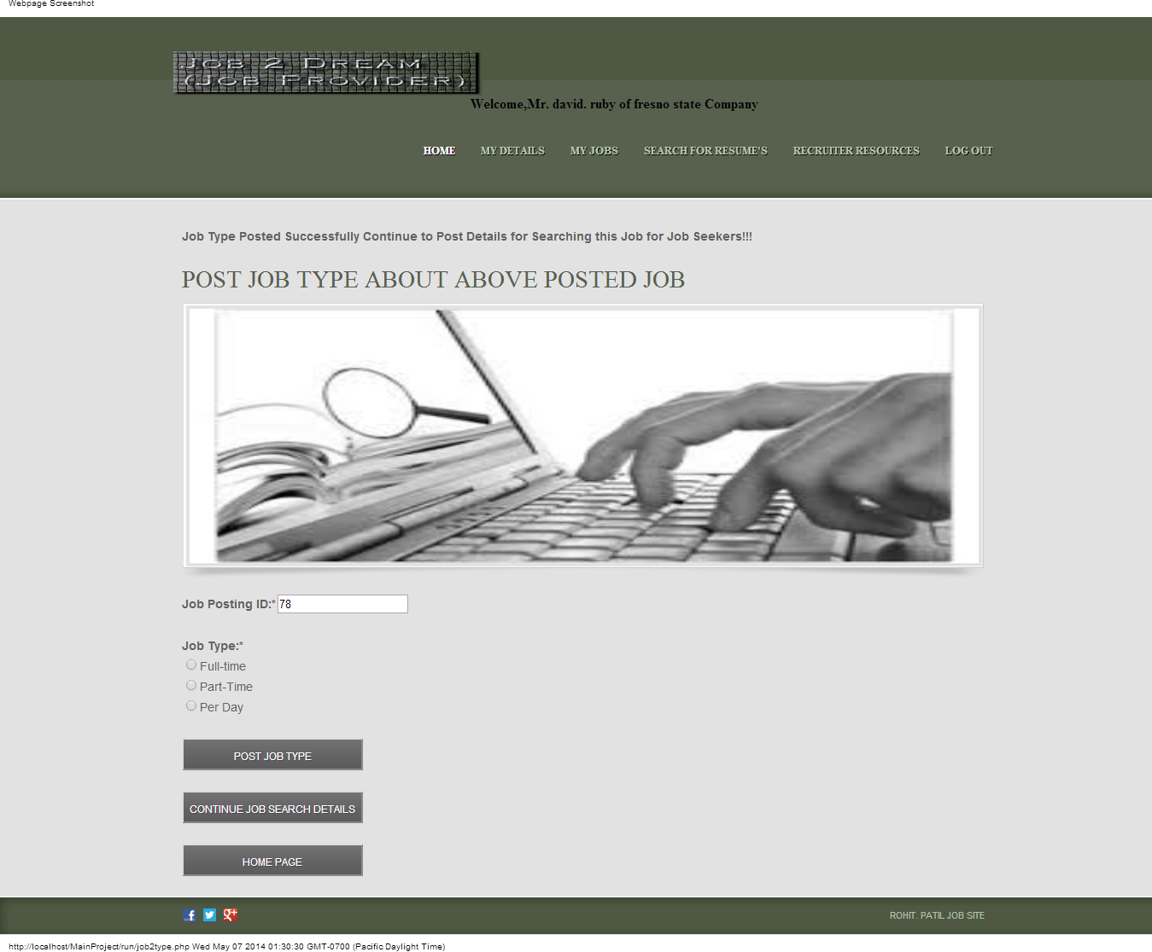

After Posting the Job Type the Job Provider Continue to Post the Job Search related for the Job Seekers through which the user can search this posted Job.

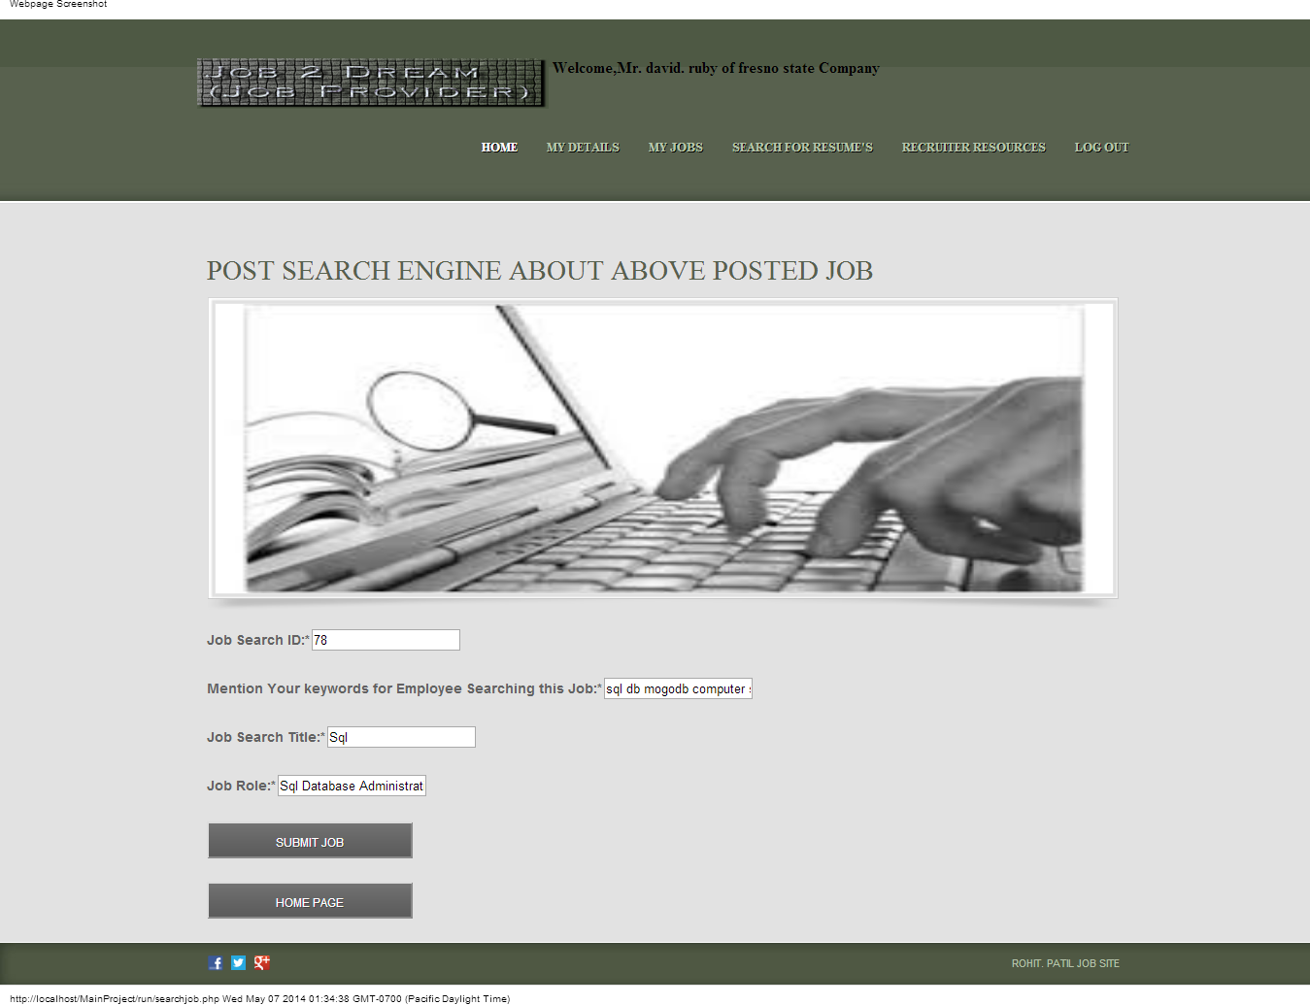

Above form is used for Posting Search related results for the Job Seekers for the above Posted Job. After posting the form the Provider gets the notification message for the posting.

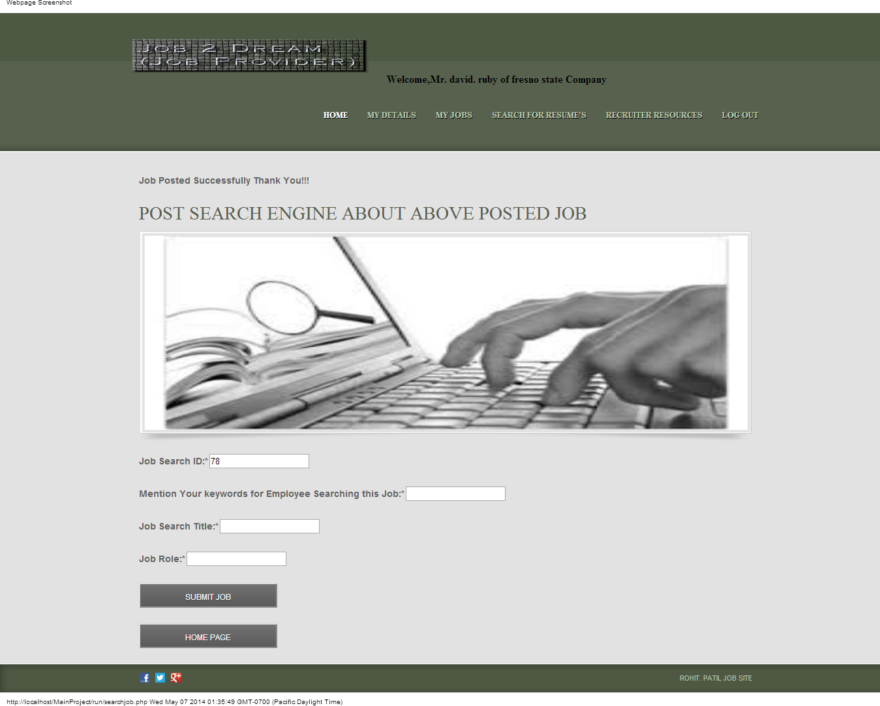

**View Advertised Jobs:**

This section is used for Job provider to see the Jobs which are posted related to his account. Below is the form which displays the advertised Jobs

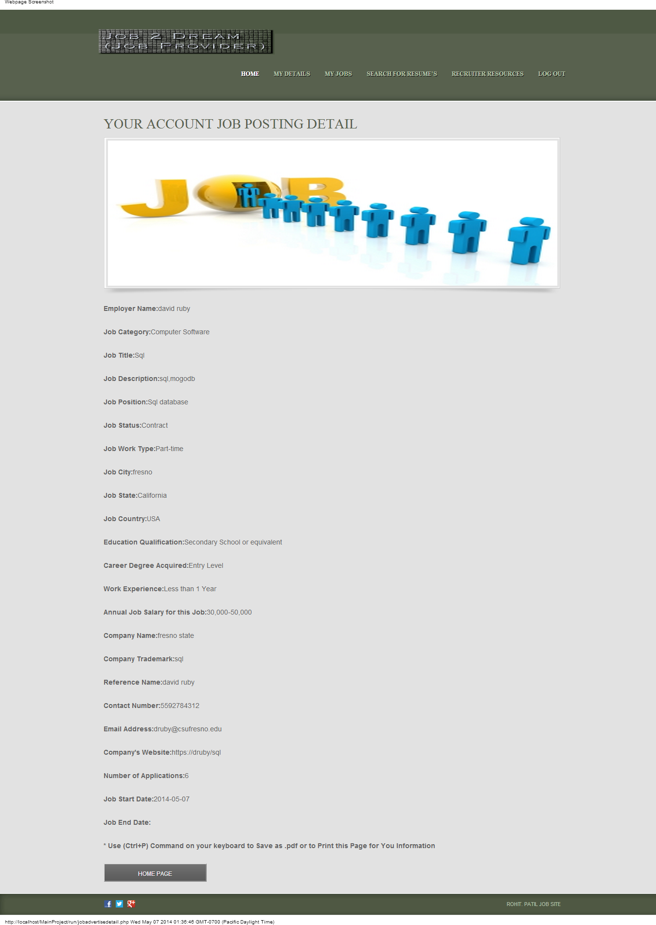

**View Job Applications:**

Job Seeker can use this section to view the Job Seekers who had applied for their Jobs.

Below is the form which displays the Job Applicants.

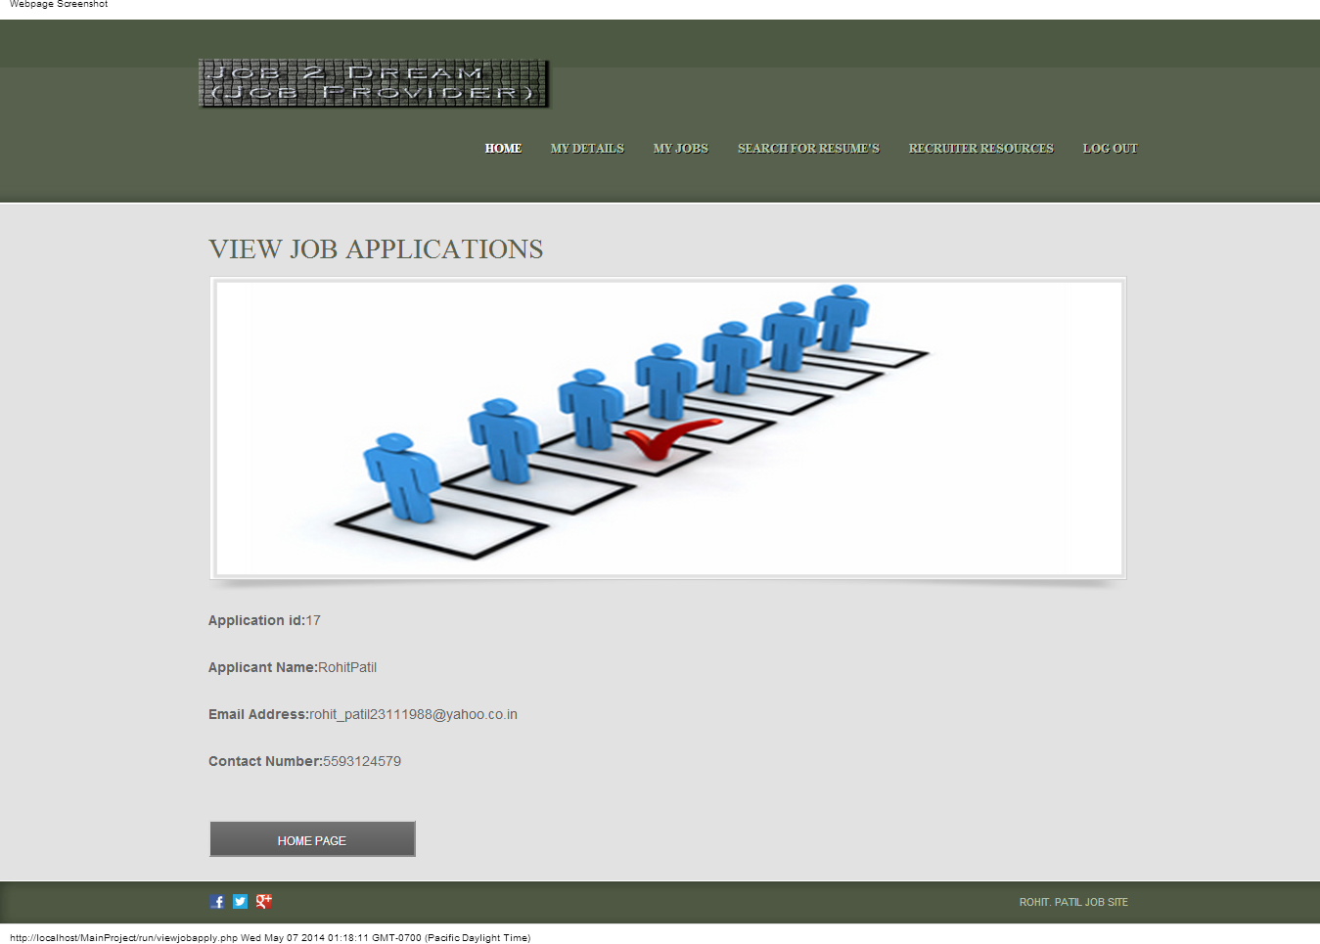

**Search for Resumes:**

Job Provider can use this section to search for the Job Seekers resume who has applied for the Job which the Job Provider has posted. Below is the form which displays the result to view the Job Applicant Resume list.

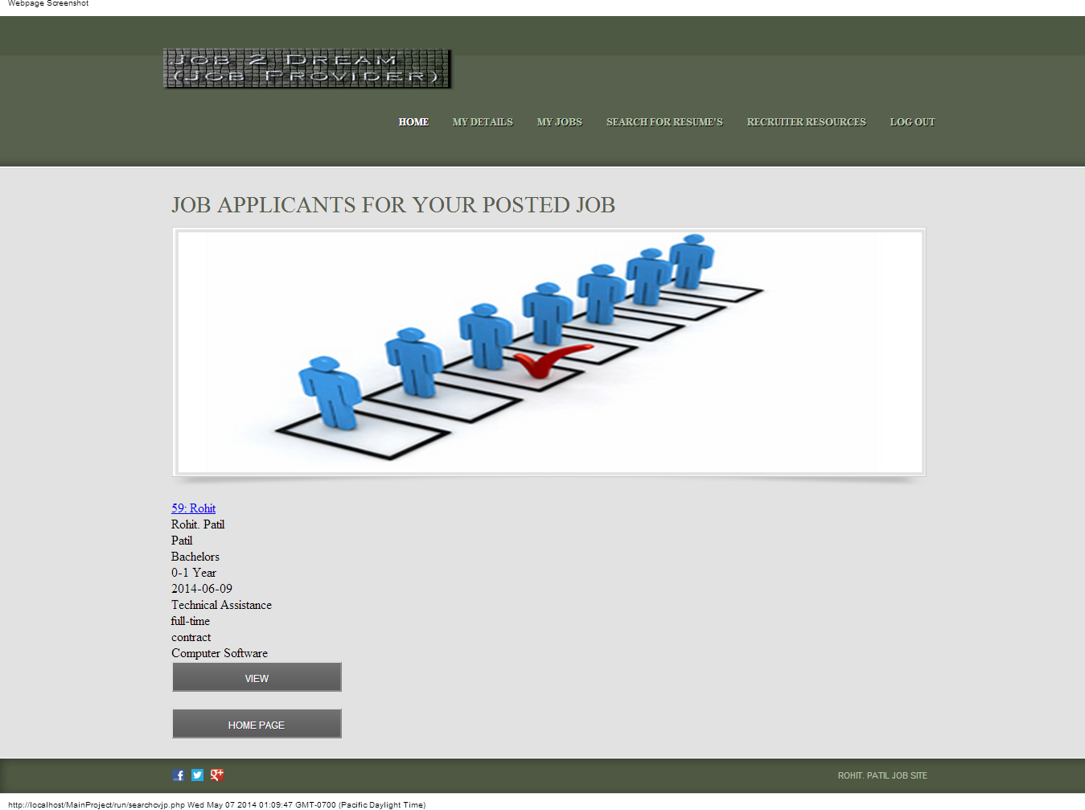

After searching the eligible candidate the Job Provider can view his resume and sends him Job Notification. Below is the form which display the details of the eligible candidate which Job Provider selects.

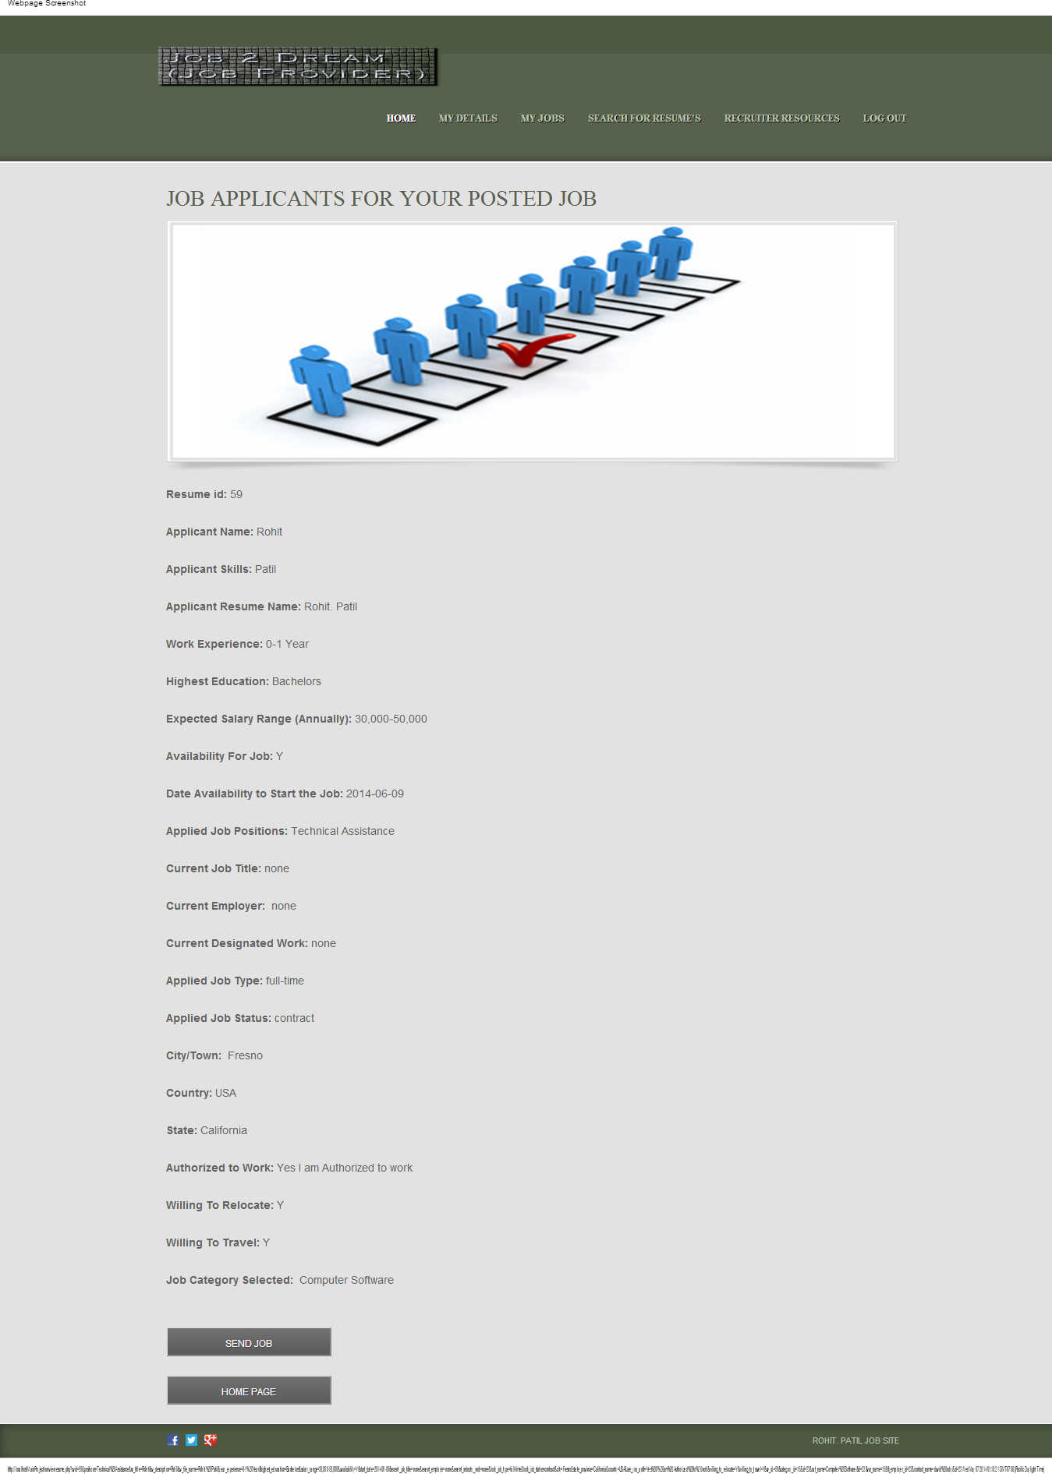

Above form displays the details of the eligible candidate and Job Provider Sends him the Job Notification through Send Job Button. Below is the form which displays the result when Job notification is sent.

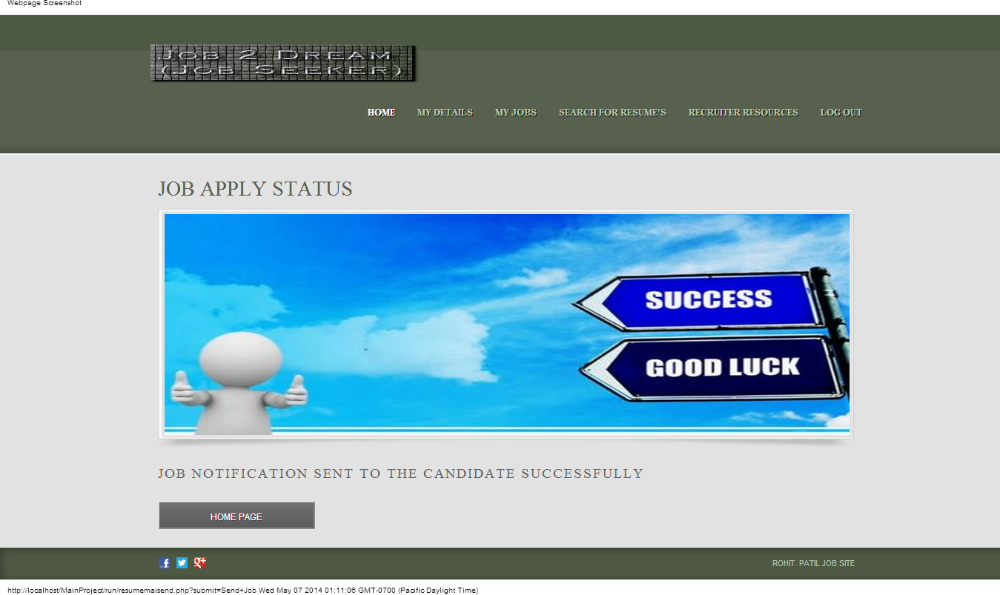

After successfully sending the Job vacancies the Job Seekers receives the mail from the Job Provider with the details of Job Providers. Below is the form which displays the result for Job notification sent to the E-mail ID

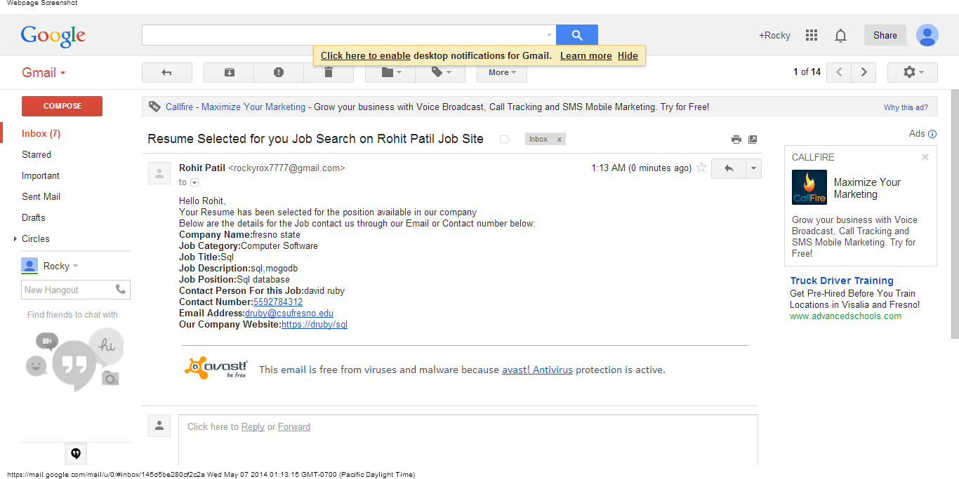

Above form display the result which shows the Job Notification sent to the eligible candidate.

**Recruiters Resources:**

This section is used to provide current Job Employment news and several tools which are helpful for the Job Provider through which he can get to know current situation of the world Job Market. Below is the form for the Recruiters section:

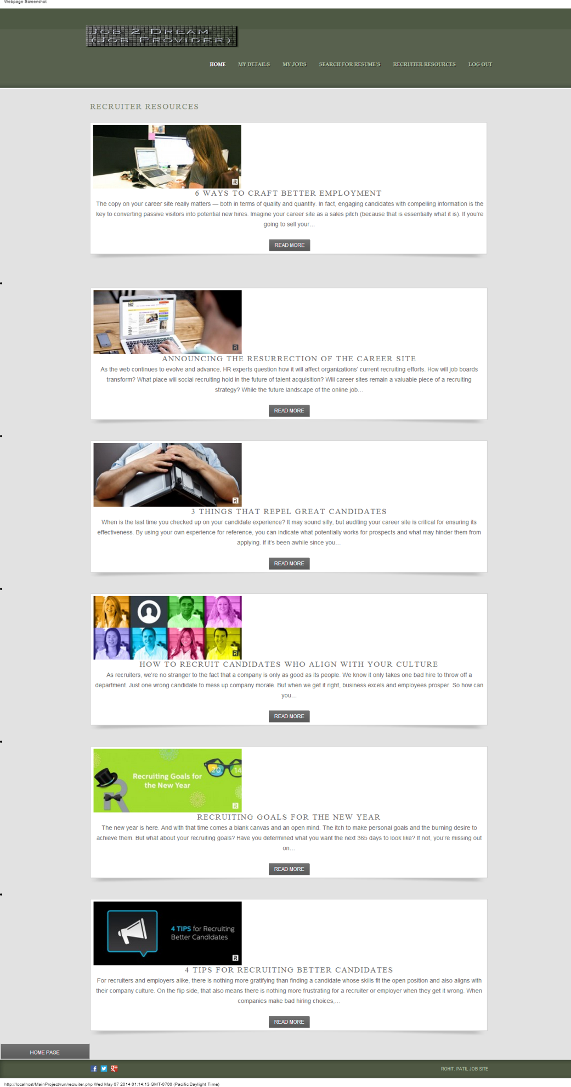

## Future Scope:

This Online Job Recruitment Website has several features which will be helpful in coming future for Job Seekers and also for Job Provider.

**Features which are useful for Job Seekers are as follows:**

* The Username and Email-ID check validation will be useful for successful registration of profiles
* The confirmation link technique used for registration will be useful for more enhanced secure registration
* The md5 password technique will give more security for the users accounts
* Automatic reload of State to its related Country will save time from searching through long lists
* Update password through the Email notification provides more secure updating of the accounts password
* The Search engine designed to search for Jobs will be more useful to search and apply for Jobs according to skill sets and also according to the Job category
* Career Advice page gives user more helpful tips and tools which are useful for his career growth
* Services Section is an ad-on feature to the training and education from several recognized websites

**Features which are useful for Job Providers are as follows:**

* The Username and Email-ID check validation will be useful for successful registration of profiles
* The confirmation link technique used for registration will be useful for more enhanced secure registration
* The md5 password technique will give more security for the users accounts
* Automatic reload of State to its related Country will save time from searching through long lists
* Update password through the Email notification provides more secure updating of the accounts password
* Advertising the Jobs through such platform is an easy access to the novice also.
* The interface is very user friendly through the Job provider gets each and every detail of the Job posting related work
* The section to view Advertised Job shows the details of the posted Job to the Job Provider
* Job Provider can use the section of the number of Job applicants through easy interface for View Job Applicants
* The main feature which will be useful in future will be searching for resumes who applied for the Job and sending Job notification for the eligible candidate accordingly
* Recruiters section through which the Job Providers get can current Job related news which will be beneficial for him for Posting the Jobs in the near furture